Fourth Test

0.

CORRECT ANSWER: E

EXPLANATION:

Yes, A,C and E should correct because there will be implicit casting will be occurred in A and C. E won’t cause any scoping error and it is called as variable shadowing. But the answer is D. Take a good look at line 4, super(); must be come first and that’s where this code fails.

EXAM OBJECTIVE: Working With Java Data Types - Declare and initialize variables (including casting of primitive data types)

FOURTH TEST - QUESTION 1/77:

Given

1. class Program{

2. Program(){ x= 10;

3. s =7;

4. super();

5. }

6. int x;

7. short s;

8. public static void main (String [ ] args){

9. System.out.print(new Program().go());

10. }

11. int go(){

12. x +=5;

13. //insert here

14. return x-s;

15. }

16. }

Which, insert independently at line 13, will compile?

A

s += 5;

B

s = s+5;

C

s *=5;

D

Int s=6;

E

Compilation fails

1.

Correct Answers: D, E

Explanation:

This is simple. In an interface, all variables are public, static and final by default. So you can declare variables using any combination of public, static and final but not others like private, etc. C is incorrect because of trying to assign double to a float without using cast (here c should be 6.0f). Option B is incorrect since variables can’t be abstract.

EXAM OBJECTIVE: : Working with Inheritance - Use abstract classes and interfaces.

Fourth Test - Question 2/77: Select Multiple Answers

Given

1. abstract interface Movable{

2. int x = 10;

3. //insert code here

4. void run();

5. }

Which, inserted independently at line 3, will compile? (Choose 2)

A

private int x = 10;

B

abstract static int i = 5;

C

final static float c = 6.0;

D

double d=6;

E

final short s=10;

2.

Correct Answer: E

Explanation:

This is somewhat tricky. At line 3, we used args.length>x++. So when it reaches to line 4, args[x] will throw ArrayIndexOutOfBoundsException. But in first invocation args.length is equal to zero so for loop condition is false, and never reach to line 4.

EXAM OBJECTIVE: Java Basics - Create executable Java applications with a main method.

Fourth Test - Question 3/77:

Given

1. class Program{

2. public static void main(String [ ] args){

3. for(int x=0;args.length>x++;){

4. System.out.print(args[x]+ " ");

5. }

6. }

7. }

And the command-line invocations are?

i. java Program

ii. java Program 12

iii. java Program 12 32

Which is true?

A

All invocations won’t throw any exceptions.

B

Only Invocation i will throw an exception.

C

Invocation ii will produce the output 12.

D

Invocation iii will produce the output 12 32.

E

Only the invocation i will complete without throwing exceptions

3.

Correct Answer: C

Explanation:

At line 2, instead of using Decimal literals, we have used octal literals. So the decimal value of x is 12 and the output is 2.

EXAM OBJECTIVE: Working With Java Data Types - Declare and initialize variables (including casting of primitive data types)

Fourth Test - Question 4/77:

Given

1. class Program{

2. int x = 014;

3. public static void main(String [] args){

4. Program pr = new Program();

5. pr.go(24);

6. }

7. void go(final int i){

8. System.out.print(i/x);

9. }

10. }

What will be the result?

A

0

B

1

C

2

D

Compilation fails due to an error on line 2.

E

Compilation fails due to an error on line 7.

4.

Correct Answer: D

Explanation:

This code has static initialization block and it will assign value 5 integer y but it is illegal to access non-static variable x in a static context. So Compilation will fail. So if we change int x to static code will compile. So answer D is correct.

EXAM OBJECTIVE: Working with Methods and Encapsulation- Apply the static keyword to methods and fields

Fourth Test - Question 5/77:

Given

1. class Program{

2. static{

3. x=10;

4. y=5;

5. }

6. final int x;

7. final static int y ;

8. public static void main(String args[]){

9. try{

10. Program pr = new Program();

11. int c = pr.x/y;

12. System.out.print(c);

13. }catch(ArithmeticException E){

14. System.out.print("Arithmetic Exception");

15. }

16. }

17. }

What will be the result?

A

0

B

2

C

Code will produce the output Arithmetic Exception.

D

Compilation fails due to an error on line 3.

E

Compilation fails due to multiple errors.

5.

Correct Answer: C

Explanation:

This is easy. First code will produce 10 11 12 13 14 15 and then when x= 16 the value of x will change to 5 so that will create an endless loop.

EXAM OBJECTIVE: Using Operators and Decision Constructs - Create and use for loops including the enhanced for loop.

Fourth Test - Question 6/77:

Given

1. class Program{

2. public static void main(String [] args){

3. for(int x = 10;x>5;x++){

4. if(x==16) x -=11;

5. System.out.print(x + “ “);

6. }

7. }

8. }

What will be the result?

A

10 11 12 13 14 15 3.

B

10 11 12 13 14 15

C

The program will hang without ever completing.

D

Compilation fails due to an error on line 4.

E

Compilation fails due to multiple errors..

6.

Correct Answer: B

Explanation:

If a method (or catch clause) does not handle an exception, the finally block is executed before the exception is propagated. Here catch clause could handle the exception thrown but in catch block it re throw the exception, hence it propagate, so finally executes and then uncaught exception pass to calling method. Hence option B is correct.

EXAM OBJECTIVE: Handling Exceptions - Create and invoke a method that throws an exception

Fourth Test - Question 7/77:

Given

1. class Program{

2. public static void main(String [] args)throws Exception {

3. try{

4. System.out.print("try Started ");

5. throw new Exception();

6. }catch(Exception e){

7. throw e;

8. }finally{

9. System.out.print("Finally Completed");

10. }

11. }

12. }

What is the result?

A

Compilation fails.

B

try Started Finally Completed followed by an exception .

C

try Started followed by an exception Finally Completed .

D

An exception is thrown at runtime without printing try Started or Finally Completed.

7.

Correct Answers: A, B, D

Explanation:

Integer.parse.Int method use to convert String to int. If String is not valid number then it throws a NumberFormatException. ArrayIndexOutOfBoundsException occurs if you use a bad index value.

EXAM OBJECTIVE : Handling Exceptions - Create a try-catch block and determine how exceptions alter normal program flow

Fourth Test - Question 8/77: Select Multiple Answers

Given

1. class Program{

2. public static void main(String [] args){

3. try{

4. int i = Integer.parseInt(args[0]);

5. System.out.print(i);

6. }catch(ArrayIndexOutOfBoundsException e){

7. System.out.println("Array Index Out Of Bounds Exception");

8. }catch(NumberFormatException e){

9. System.out.println("Number Format Exception");

10. }

11. }

12. }

And the command-line invocations are

i. java Program

ii. java Program 12

iii. java Program A

iv. java Program 12 24

Which are true? (Choose 3)

A

Invocation i will print Array Index Out Of Bounds Exception.

B

Invocation ii will print will print 12.

C

Invocation iii will print Array Index Out Of Bounds Exception.

D

Invocation iii will print Number Format Exception.

E

Invocation iv will print Array Index Out Of Bounds Exception.

8.

Correct Answer: C

Explanation:

This code fails the compilation because here, we used the keyword synchronized with variable and it is illegal.

EXAM OBJECTIVE: Working With Java Data Types - Declare and initialize variables (including casting of primitive data types)

Fourth Test - Question 9/77:

Given

1. class Access{

2. synchronized int AccessCode;

3. transient Integer AccessCode2 = 1000;

4. Access(int i){

5. AccessCode = i;

6. }

7. public static void main(String args[]){

8. System.out.print(new Access(1020).AccessCode);

9. }

10. }

What is the result?

A

0

B

1020.

C

Compilation fails due to an error on line 2.

D

Compilation fails due to an error on line 3.

9.

Correct Answer: C

Explanation:

The case constant has to be a compile time constant, here only B, C and D marked as final (constant) but we can’t use the private access modifier with local variables and if the x=2 then the code won’t compile because there are two cases which has same case constant (1 and x-1).

EXAM OBJECTIVE: Using Operators and Decision Constructs - Use a switch statement.

Fourth Test - Question 10/77:

Given

1. class SwitchTest{

2. public static void main(String [] args){

3. final int s =2;

4. //insert code here

5. switch(s){

6. case 1 :System.out.print("A");break;

7. case x-1 :System.out.print("B");

8. case x :System.out.print("C");break;

9. case x+1 :System.out.print("D");break;

10. default :System.out.print("F");

11. }

12. }

13. }

Which, inserted independently at line 3, will compile and produce BC?

A

int x=2;

B

final int x=2;

C

final int x=3;

D

private final int x = 3;

E

Nothing will produce compile and produce BC.

10.

Correct Answer: E

Explanation:

You must never ever try to specify a size when using anonymous array creation syntax. The size is derived from the number of elements between the curly braces. So compilation fails due to error at line 3. It should be

new Program().iterator(new int []{10,12,13});

EXAM OBJECTIVE: Using Operators and Decision Constructs - Create and use for loops including the enhanced for loop.

Fourth Test - Question 11/77:

Given

1. class Program{

2. public static void main(String args[]){

3. new Program().iterator(new int [3]{10,12,13});

4. }

5. void iterator(int []i){

6. for(int x=0;x<i.length;System.out.print(i[x] + " ")) x++;

7. }

8. }

What will be the result?

A

10 12 13

B

12 13

C

10 12.

D

12 13 followed by an exception

E

Compilation fails

11.

Correct Answer: A

Explanation:

When we overload a method we must change the argument list and we can throw different exceptions. We can have different access modifiers. So the eat method doesn’t cause any problem. Though variable has Animal reference type, it is dog object and there is no issue when we cast it to be a dog object.

EXAM OBJECTIVE: Working with Inheritance - Develop code that demonstrates the use of polymorphism; including overriding and object type versus reference type

Fourth Test - Question 12/77:

Given

1. class Animal{

2. public void eat()throws NullPointerException{

3. System.out.print("Animal eats ");

4. }

5. }

6. class Dog extends Animal{

7. void eat(String s)throws Exception{

8. System.out.print("Dog eats "+ s);

9. }

10. }

11. public class Program{

12. public static void main (String [] args)throws Exception{

13. Animal a= new Dog();

14. Dog d = (Dog)a;

15. a.eat();

16. d.eat("Meat");

17. }

18. }

What will be the result?

A

Animal eats Dog eats Meat

B

Animal eats Animal eats

C

Compilation fails due to an error on line 17

D

An exception will be thrown at runtime.

E

Compilation fails due to an error on line 19

12.

Correct Answer: A

Explanation:

When we overload a method we must change the argument list and we can throw different exceptions. We can have different access modifiers. So the eat method doesn’t cause any problem. Though variable has Animal reference type, it is dog object and there is no issue when we cast it to be a dog object.

EXAM OBJECTIVE: Working with Inheritance - Develop code that demonstrates the use of polymorphism; including overriding and object type versus reference type

Fourth Test - Question 12/77:

Given

1. class Animal{

2. public void eat()throws NullPointerException{

3. System.out.print("Animal eats ");

4. }

5. }

6. class Dog extends Animal{

7. void eat(String s)throws Exception{

8. System.out.print("Dog eats "+ s);

9. }

10. }

11. public class Program{

12. public static void main (String [] args)throws Exception{

13. Animal a= new Dog();

14. Dog d = (Dog)a;

15. a.eat();

16. d.eat("Meat");

17. }

18. }

What will be the result?

A

Animal eats Dog eats Meat

B

Animal eats Animal eats

C

Compilation fails due to an error on line 17

D

An exception will be thrown at runtime.

E

Compilation fails due to an error on line 19

13.

Correct Answer: A

Explanation:

Variable p and s refer to same object type Liver at though they have different reference type. So invoking read methods invokes the same overridden method. The other method is not overridden because the other method in the SuperClass (Person ) marked as private.

EXAM OBJECTIVE: Working with Java Data Types - Know how to read or write to object fields

Fourth Test - Question 14/77:

Given

1. class Person{

2. int age;

3. String name;

4. public void read(){

5. System.out.print("Person is reading ");

6. }

7. private void other(){}

8. }

9. class Livera extends Person{

10. Livera(String s ,int i){

11. age = i;

12. name = s;

13. }

14. public void read(){

15. System.out.print(name +" is reading ");

16. }

17. public void other()throws Exception{}

18. }

19. public class Program{

20. public static void main(String [] args){

21. Livera s = new Livera("Livera" , 22);

22. Person p = s;

23. s.read();

24. p.read();

25. }

26. }

What will be the result?

A

Livera is reading Livera is reading

B

Livera is reading person is reading

C

An exception will be thrown at runtime.

D

Compilation fails due to an error on line 22

E

None of above.

14.

Correct Answer: E

Explanation:

Everything is fine in this code but a final class cannot be extended. So compilation fails because SubSub class extends Sub class which has marked with final.

EXAM OBJECTIVE: Working With Java Data Types - Differentiate between object reference variables and primitive variables

Fourth Test - Question 15/77:

Given

1. class SuperClass{

2. public void method(){

3. System.out.print("SuperClass");

4. }

5. }

6. final class Sub extends SuperClass{

7. public void method(){

8. System.out.print("SubClass");

9. }

10. }

11. public class SubSub extends Sub{

12. public static void main(String args[]){

13. ((SuperClass)new SubSub()).method();

14. }

15. public void method(){

16. System.out.print("SubsubClass");

17. }

18. }

What will be the result?

A

The output will produce SubsubClass

B

The output will produce SubClass

C

The output will produce SuperClass

D

An exception will be thrown at runtime.

E

Compilation fails

15.

Correct Answer: B

Explanation:

To get correct answer, you should know, Static initialization blocks run once, when the class is first loaded. Instance initialization blocks run every time a new instance is created. They run aprer all super-constructors and before the constructor’s code have run.

EXAM OBJECTIVE: Working with Inheritance - Create and overload constructors; including impact on default constructors

Fourth Test - Question 16/77:

Given

1. class MainClass{

2. MainClass(){ System.out.print("MainClass "); }

3. }

4. class SubClass extends MainClass{

5. {System.out.print("I ");}

6. static{System.out.print("S ");}

7. SubClass(int i){

8. this();

9. System.out.print("SubClass ");

10. }

11.

12. SubClass(){

13. super();

14. System.out.print("SubClass ");

15. }

16. }

17. public class SubSubClass extends SubClass{

18. SubSubClass(String s){

19. super();

20. System.out.print("SubSubClass ");

21. }

22. public static void main(String [] args){

23. new SubSubClass("ABC");

24. }

25. }

What will be the result?

A

MainClass S I SubClass SubSubClass

B

S MainClass I SubClass SubSubClass

C

S MainClass I SubClass SubClass SubSubClass

D

SubSubClass SubClass S I MainClass

E

Compilation fails

16.

Correct Answer: E

Explanation:

You must include the size of an array when you construct it (using new) if it is not an anonymous array. It is never legal to include the size of array in the declaration so option D is incorrect. Options A and B are incorrect since we haven’t give size for the first dimension.

Option C is incorrect since we can’t use # for the variable names.

EXAM OBJECTIVE: Creating and Using Arrays - Declare, instantiate, initialize and use a one-dimensional array

Fourth Test - Question 17/77:

Which of the following is valid array initialization/s.

A

int [] array [] = new int [][];

B

int [][] two = new int [][5];

C

Int #one [] = new int [5];

D

int [3][] three = new int [][];

E

int [] one = new int [6];

17.

Correct Answer: A

Explanation:

Only option A is invalid, as we should change the argument list when overloading method. So option C is valid statement. We can change the return type also hence option D is valid statement.

When method overriding methods we should not change the argument list, so option B is valid.

In Overloaded methods, object type determines which method selected so option E is valid.

EXAM OBJECTIVE: Working with Methods and Encapsulation - Create methods with arguments and return values; including overloaded methods

Fourth Test - Question 18/77:

Which is invalid?

A

Overloaded methods may change the argument list.

B

Overridden methods should not change the argument list.

C

Overloaded methods must change the argument list.

D

Overloaded methods can change return type.

E

In Overloaded methods, object type determines which method selected.

18.

Correct Answers: C, D

Explanation:

JVM exceptions – exceptions or errors thrown by the JVM .

Programmatic exceptions are thrown explicitly by application or API programmers. [AssertionError. llegalArgumentException, etc]

EXAM OBJECTIVE: Handling Exceptions - Differentiate among checked exceptions, unchecked exceptions, and Errors

Fourth Test - Question 19/77: Select Multiple Answers

Which is/are typically thrown by the JVM? (Choose 2)

A

IllegalStateException

B

IllegalArgumentException

C

StackOverflowError

D

ArrayIndexOutOfBoundsException

E

AssertionError

19.

Correct Answer: D

Explanation:

The check method accept only short variable but at line 3 code tries to invoke test method using int variable. If we use a cast as (short)10 then the code will work fine.

EXAM OBJECTIVE: Working With Java Data Types -Declare and initialize variables (including casting of primitive data types)

Fourth Test - Question 20/77:

Given

1. class Program{

2. public static void main(String args[]) throws Exception{

3. System.out.print(new Program().check(10));

4. }

5. boolean check(short x){

6. if(x<10) return true;

7. else return false;

8. }

9. }

What will be the result?

A

false.

B

true

C

An exception is thrown at runtime

D

Compilation fails due to an error on line 3

E

Compilation fails due to multiple errors

20.

Correct Answer: A

Explanation:

Code will compile fine and produce true as output. Wrappers are type of object so it returns true.

EXAM OBJECTIVE: Working With Java Data Types -Declare and initialize variables (including casting of primitive data types)

Fourth Test - Question 21/77:

Given

1. class Program{

2. public static void main(String[] args) {

3. Integer x = 10;

4. System.out.print(x instanceof Object);

5. }

6. }

What is the output?

A

true

B

false

C

Compilation fails due to error at line 3.

D

Compilation fails due to error at line 4.

21.

Correct Answer: D

Explanation:

Here we have used casting to convert two dimensional array to one dimensional array. So array b is equal to second element (it is an array too!) of array a. Second element of array b is 2.

EXAM OBJECTIVE: Creating and Using Arrays - Declare, instantiate, initialize and use a one-dimensional array

Fourth Test - Question 22/77:

Given

1. class Program{

2. public static void main(String[] args) {

3. int a[][] = { {1,2,4} , {5,2,1}, {0,43,2}};

4. int b[] = (int[])a[2];

5. System.out.print(b[2]);

6. }

7. }

Which is the output?

A

4

B

5

C

43

D

2

E

Compilation fails due to line 4

22.

Correct Answer: D

Explanation:

Indexing of array elements begin with zero. So index position one refers to the second element in an array. So here a[3] refers to the fourth element of array a. and we have assigned octal value to a[2] so the value of element is 43 in decimals.

EXAM OBJECTIVE: Creating and Using Arrays - Declare, instantiate, initialize and use multi-dimensional array

Fourth Test - Question 23/77:

Given

1. class Program{

2. public static void main(String[] args) {

3. int a[] = { 1,2,053,4};

4. int b[][] = { {1,2,4} , {2,2,1}, {0,43,2}};

5. System.out.print(a[3]==b[0][2] );

6. System.out.print(" " + (a[2]==b[2][1]));

7. }

8. }

Which is the output?

A

true false

B

false false

C

false true

D

true true

E

Compilation fails

23

Correct Answer: D

Explanation:

We have used several steps to complete the creation of two dimensional array and using anonymous arrays we have assigned two int arrays to the two dimensional array a.

EXAM OBJECTIVE: Creating and Using Arrays - Declare instantiate, initialize and use multi-dimensional array

Fourth Test - Question 24/77:

Given

1. class Program{

2. public static void main(String[] args) {

3. int a[][] = new int[3][];

4. a[1] = new int[]{1,2,3};

5. a[2] = new int[]{4,5};

6. System.out.print(a[1][1]);

7. }

8. }

Which is the output?

A

Compilation fails due to line 3.

B

Compilation fails due to line 4.

C

Exception will be thrown in runtime.

D

2

E

3

F

5.

2

Correct Answer: C

Explanation:

Inside a class method, when a local variable have the same name as one of the instance variable, the local variable shadows the instance variable inside the method block. So the value of a in method print() can see as the output.

EXAM OBJECTIVE: Java Basics - Define the scope of variables

Fourth Test - Question 25/77:

Given

1. class Program{

2. int a=10;

3. public static void main(String[] args) {

4. new Program().print();

5. }

6. public void print(){

7. int a = 8;

8. System.out.print(a + " ");

9. }

10. }

Which is the output?

A

10.

B

18

C

8

D

Compilation fails.

25.

CORRECT ANSWER: E

EXPLANATION:

Teacher class has constructor which can take String as argument but it is marked as private so it can’t be seen by the Test class. So that’s why this code fails.

EXAM OBJECTIVE: Working with Methods and Encapsulation - Create and overload constructors; including impact on default constructors

FOURTH TEST - QUESTION 26/77:

Given

1. class Person{

2. Person(){

3. System.out.print("CP ");

4. }

5. static{ System.out.print("SP ");}

6. }

7.

8. class Student extends Person{

9. Student(){

10. System.out.print("CS ");

11. }

12. }

13.

14. class Teacher extends Person{

15. Teacher(){

16. System.out.print("CT ");

17. }

18. private Teacher(String s){

19. System.out.print("OCT ");

20. }

21. }

22.

23. class Program{

24. public static void main(String [] args){

25. Person p1 = new Teacher(“name”);

26. Student s1 = new Student();

27. }

28. }

What is the output?

A

SP OCT CP SP CS

B

SP CP IT OCT CP CS

C

SP CP OCT CP CS

D

SP CP OCT CT SP CP CS

E

Compilation fails.

26.

CORRECT ANSWER: E

EXPLANATION:

A case constant must be compile time constant. Here integer j is not a compile time constant.

EXAM OBJECTIVE: Using Operators and Decision Constructs - Use a switch statement.

FOURTH TEST - QUESTION 27/77:

Given

1. class Program{

2. public static void main(String args[]){

3. final int i = 0;

4. final int j;

5. j=2;

6. int x= (int)(Math.random() * 3);

7.

8. switch(x){

9. case i: {System.out.print("A");}

10. case 1: System.out.print("B"); break;

11. case j: System.out.print("C");

12. }

13. }

14. }

Note: Math.random() * 3 will assign value 0,1 or 2 x.

What is true?

A

The output could be A

B

The output could be AB

C

The output could be B

D

The output could be BC

E

Compilation fails.

27.

CORRECT ANSWER: A

EXPLANATION:

Option A is correct as if statement can evaluate only Boolean expressions.

Option E is incorrect since the switch statements can evaluate only to enums , byte, short ,int and char data types and string.

The default keyword is optional hence option D is incorrect. The curly braces are options for if blocks so option B is incorrect.

EXAM OBJECTIVE: Using Operators and Decision Constructs - Use a switch statement.

FOURTH TEST - QUESTION 28/77:

Choose the correct statements.

A

The only legal expression in an if statement is a Boolean expression

B

Curly braces are essential for if blocks.

C

Switch statement can evaluate float data type.

D

The default key word is a must for switch statement.

E

double can be used as case constant.

28.

CORRECT ANSWER: B

EXPLANATION:

In each iteration of the outer loop, inner loop prints elements of a, in inner loop we have placed printing statement in for loop updating portion which is legal. When j is equal to two, current iteration stops as if calls continue. So there will be 123 on first and third iteration process. Hence option B is correct.

EXAM OBJECTIVE: Using Operators and Decision Constructs - Use break and continue.

FOURTH TEST - QUESTION 29/77:

Given

1. class Program{

2. public static void main(String args[]){

3. int []a = {1,2,3};

4.

5. for(int j : a){

6. if(j==2) continue;

7. for(int x = 0;x<3;System.out.print(x)){ x++;}

8. }

9. }

10. }

What is the output?

A

123

B

123123

C

123123123

D

Compilation fails.

E

Will print 123 and then goes to never ending loop.

29.

CORRECT ANSWER: D

EXPLANATION:

This is nested loop. In outer for loop there is no variable defined as y. Outer loop can’t see the variables in inner loop so trying to use inner loop variable y at line 5 causes a compile time error. Hence option D is correct.

EXAM OBJECTIVE: Using Operators and Decision Constructs - Use break and continue.

FOURTH TEST - QUESTION 30/77:

Given

1. class Program{

2. public static void main(String args[]){

3.

4. Loop1: for(int x = 0;x<5;x++){

5. if(y==3) break Loop1;

6. for(int y = 0;y<3;y++){

7. if(y==2) continue Loop1;

8. System.out.print(y);

9. }

10. }

11. }

12. }

What is the output?

A

0101010101

B

123123

C

123123123

D

Compilation fails.

E

Will print 123 and then goes to never ending loop.

30.

CORRECT ANSWER: D

EXPLANATION:

This is nested loop. In outer for loop there is no variable defined as y. Outer loop can’t see the variables in inner loop so trying to use inner loop variable y at line 5 causes a compile time error. Hence option D is correct.

EXAM OBJECTIVE: Using Operators and Decision Constructs - Use break and continue.

FOURTH TEST - QUESTION 30/77:

Given

1. class Program{

2. public static void main(String args[]){

3.

4. Loop1: for(int x = 0;x<5;x++){

5. if(y==3) break Loop1;

6. for(int y = 0;y<3;y++){

7. if(y==2) continue Loop1;

8. System.out.print(y);

9. }

10. }

11. }

12. }

What is the output?

A

0101010101

B

123123

C

123123123

D

Compilation fails.

E

Will print 123 and then goes to never ending loop.

31.

CORRECT ANSWER: C

EXPLANATION:

Every time y equals 2, loop will not reach to second if statement so, there is no influence of second if statement to the output. So “01” will be printed three times.

EXAM OBJECTIVE: Using Operators and Decision Constructs - Create and use for loops including the enhanced for loop

FOURTH TEST - QUESTION 32/77:

Given

1. class Program{

2. public static void main(String args[]){

3.

4. Loop1:for(int x = 0;x<3;x++){

5. for(int y = 0;y<3;y++){

6. if(y==2) continue;

7. if(y==2 && x==2)break Loop1;

8. System.out.print(y);

9. }

10. }

11. }

12. }

What is the output?

A

01010101

B

000

C

010101

D

Compilation fails.

32.

CORRECT ANSWER: D

EXPLANATION:

First if statement evaluates value of x and when saw it is false it won’t evaluate the value of y. So in this if statement only the value of x changes but the value of y won’t. In second if statement evaluating value of y return true so it won’t evaluate the value of x, so the value of x won’t change. So the final value of x will be 1 and y will be 11.

EXAM OBJECTIVE: Using Operators and Decision Constructs - Create if and if/else and ternary constructs

FOURTH TEST - QUESTION 33/77:

Given

1. class Program{

2. public static void main(String args[]){

3. int x = 0, y = 10;

4.

5. if(x++ > 1 && ++y >10)

6. System.out.print(x + y);

7. if(++y > 10 || ++x >10)

8. System.out.print(x + y);

9. }

10. }

What is the output?

A

No output

B

1112

C

1012

D

12

E

13

33.

CORRECT ANSWER: D

EXPLANATION:

Methods in the Arrays class throw a NullPointerException, if the specified array reference is null. So here we haven't initialized the ints[1], so it is null. Hence passing it to Arrays toString method throws a NullPointerException so option D is correct.

EXAM OBJECTIVE : Creating and Using Arrays - Declare instantiate, initialize and use a one-dimensional array.

FOURTH TEST - QUESTION 34/77:

Given

1. import java.util.Arrays;

2.

3. public class Program{

4. public static void main(String[] args) {

5. int[][] ints = new int[2][];

6.

7. Arrays.sort(ints[1]);

8.

9. System.out.print(Arrays.toString(ints[1]));

10. }

11. }

Which is the output?

A

[0, 0, 0]

B

[null,null,null]

C

null

D

NullPointerException

E

Compilation fails.

34.

CORRECT ANSWER: E

EXPLANATION:

String class has method called toCharArray which returns an array of characters of given string, also String class has a constructor which can take char array and create string, but StringBuilder class doesn’t have toCharArray method. Hence code fails to compile because of line 4, so option E is correct.

EXAM OBJECTIVE : Working with Selected classes from the Java API - Manipulate data using the StringBuilder class and its methods

FOURTH TEST - QUESTION 35/77:

Given

1. class Program{

2. public static void main(String[] args){

3. StringBuilder sb =new StringBuilder("OCAJP");

4. String s = new String(sb.toCharArray());

5. s = s.concat(" 8");

6. System.out.print(s);

7. }

8. }

What is the result?

A

OCAJP 8

B

OCAJP

C

8

D

An Exception.

E

Compilation fails.

35.

CORRECT ANSWER: B

EXPLANATION:

At line 3 we have created StringBuilder instance by passing “aAaA”. Then at line 4, we have used one of the overloaded versions of the insert method of the StringBuilder

public StringBuilder insert(int offset, boolean b)

Inserts the string representation of the boolean argument into this sequence.

The overall effect is exactly as if the second argument were converted to a string by the method String.valueOf(boolean), and the characters of that string were then inserted into this character sequence at the indicated offset.

The offset argument must be greater than or equal to 0, and less than or equal to the length of this sequence.

Here we have passed the index of the last “A” as the so true will be inserted before the last occurrence of “A”, hence option B is correct.

EXAM OBJECTIVE : Working with Selected classes from the Java API - Manipulate data using the StringBuilder class and its methods

FOURTH TEST - QUESTION 36/77:

Given

1. class Program{

2. public static void main(String[] args){

3. StringBuilder sb =new StringBuilder("aAaA");

4. sb.insert(sb.lastIndexOf("A"),true);

5. System.out.print(sb);

6. }

7. }

What is the result?

A

aAtrueaA

B

aAatrueA

C

atrueAaA

D

A StringIndexOutOfBoundsException

E

Compilation fails.

36.

CORRECT ANSWER: D

EXPLANATION:

We have replaced the first and only “80” occurrence with “81” at line 5, so there won’t be any occurrence of “80” in the s1, so indexOf method will return -1 when we check index of the “80”. At line 6, we tried substring by passing -1 , which result an exception hence option D is correct.

EXAM OBJECTIVE : Working with Selected classes from the Java API - Creating and manipulating Strings

FOURTH TEST - QUESTION 37/77:

Given

1. class Program{

2. public static void main(String[] args){

3.

4. String s1 = "1Z0-808";

5. s1 = s1.replace("80", "81");

6. String str = s1.substring(s1.indexOf("80"), s1.lastIndexOf("8"));

7.

8. System.out.print(str);

9. }

10. }

What is the output?

A

08

B

80

C

No output will be printed.

D

An Exception.

E

Compilation fails.

37.

CORRECT ANSWER: D

EXPLANATION:

The String class has a method called length which returns the number of characters in given string.

public int length()

This returns the length of this string. The length is equal to the number of Unicode code units in the string.

EXAM OBJECTIVE : Working with Selected classes from the Java API - Creating and manipulating Strings

FOURTH TEST - QUESTION 38/77:

Which can be used to get the number of characters in a string object?

A

size()

B

capacity

C

length

D

length()

E

None of above.

38.

CORRECT ANSWER: E

EXPLANATION:

Java SE 8 only introduced one new method called join in String class.

public static String join(CharSequence delimiter,CharSequence... elements)

Returns a new String composed of copies of the CharSequence elements joined together with a copy of the specified delimiter.

For example,

String message = String.join("-", "Java", "is", "cool");

// message returned is: "Java-is-cool"

All given methods are introduced before to java se 8 so option E is correct.

EXAM OBJECTIVE : Working with Selected classes from the Java API - Creating and manipulating Strings

REFERNCE : http://docs.oracle.com/javase/tutorial/java/data/strings.html

FOURTH TEST - QUESTION 39/77:

Which of the following method of String class introduced in java SE 8?

A

split

B

replaceFirst

C

append

D

set

E

None of above

39.

CORRECT ANSWER: D

EXPLANATION:

All except length which is invalid method are valid methods available in ArrayList, however from given methods only the spliterator introduced from java SE 8, others were available from earlier versions of java.

EXAM OBJECTIVE : Working with Selected classes from the Java API - Declare and use an ArrayList of a given type

FOURTH TEST - QUESTION 40/77:

Which of the following method available in ArrayList from java SE 8?

A

length

B

retainAll

C

listIterator

D

spliterator

E

None of above.

40.

CORRECT ANSWER: A

EXPLANATION:

There are few versions of add method, at line 10 we have used following version,

public void add(int index,E element)

This inserts the specified element at the specified position in this list. Shifts the element currently at that position (if any) and any subsequent elements to the right (adds one to their indices).

So here B will be added after C, and remain elements will be shifted accordingly.

At line 13, the set method will change the element of the given index position, so here D will be replaced by F, hence list will contain A,B,C,E and F. Hence option A is correct.

EXAM OBJECTIVE : Working with Selected classes from the Java API - Declare and use an ArrayList of a given type

FOURTH TEST - QUESTION 41/77:

Given

1. public class Program {

2. public static void main(String[] args){

3. List<String> list = new ArrayList< >();

4.

5. list.add("A");

6. list.add("C");

7. list.add("E");

8. list.add("D");

9.

10. list.add(1, "B");

11. list.set(4, "F");

12.

13. System.out.println(list);

14. }

15. }

What is the output?

A

[A, B, C, E, F]

B

[A, C, E, F]

C

[A, B, C, F, E]

D

An Exception is thrown.

E

Compilation fails.

41.

CORRECT ANSWER: E

EXPLANATION:

From java SE 7 we can use diamond operator so we can skip the generic part of the object initializing since the compiler figure out what it should be, for example following are same

ArrayList<Book > library = new ArrayList< >();

ArrayList<Book > library = new ArrayList<Book>();

The default capacity of the array list is 10, and we can also create arraylist with the capacity we need, so here all options are correct.

EXAM OBJECTIVE : Working with Selected classes from the Java API - Declare and use an ArrayList of a given type

FOURTH TEST - QUESTION 42/77:

What statement could you use to declare and instantiate an ArrayList object reference of Book objects named library with a default capacity of 10 elements?

A

ArrayList<Book > library = new ArrayList< >();

B

ArrayList<Book > library = new ArrayList< >(10);

C

ArrayList<Book > library = new ArrayList<Book>(10);

D

ArrayList<Book > library = new ArrayList<Book>();

E

All of above.

42.

CORRECT ANSWER: A

EXPLANATION:

All collection class has method call size which returns the number of elements in the collection, so option A is correct.

Option B and C are incorrect since there are no such variables.The length method is used with the strings.

EXAM OBJECTIVE : Working with Selected classes from the Java API - Declare and use an ArrayList of a given type

FOURTH TEST - QUESTION 43/77:

Which can be used to get the number of elements in an ArrayList object?

A

size()

B

capacity

C

length

D

length()

E

None of above.

43.

CORRECT ANSWER: D

EXPLANATION:

When all adding done, content of the a will be 7,10 and 21. Once set method called it will change the value of index position 1, which is 10 to 4. Then removing first element will remove the 7, hence the index position 1 will contain 21, hence option D is correct.

EXAM OBJECTIVE : Working with Selected classes from the Java API - Declare and use an ArrayList of a given type

FOURTH TEST - QUESTION 44/77:

After the following code sequence is executed, what are the contents at ArrayList index 1 in a?

ArrayList<Integer> a = new ArrayList<Integer>( );

a.add( 7 );

a.add( 10 );

a.add( 21 );

a.set( 1, 4 );

a.remove( 0 );

A

10

B

7

C

4

D

21

E

0

44.

CORRECT ANSWER: C

EXPLANATION:

First Line we have created Year object with year 2015, then at line 2, invoking atDay method will create local date object with the given day of the year, since it is 12 date will be equal to 12th Jan. Since it returns a LocalDate object option C is correct.

EXAM OBJECTIVE : Working with Selected classes from the Java API - Create and manipulate calendar data using classes from java.time.LocalDateTime, java.time.LocalDate, java.time.LocalTime, java.time.format.DateTimeFormatter, java.time.Period

FOURTH TEST - QUESTION 45/77:

Given code fragment

Year y = Year.of(2015);

_______ ym = y.atDay(12);

Which of the following can be used to fill the blank?

A

YearMonth

B

Month

C

LocalDate

D

Date

E

LocalDateTime

45. CORRECT ANSWER: B

EXPLANATION:

Here we have called format method which returns string according to the passed date time formatter. The DateTimeFormatter.BASIC_ISO_DATE field format date it to following format (for example in this case : 2014.43.13)

20140413

So in given code we have passed year as 2011 and atMonthDay invokes on the result year by passing MonthDay with values 2 as month and 23 as the day, so result date will be 2011-02-23. Hence the output will be 20110223. So option B is correct.

EXAM OBJECTIVE : Working with Selected classes from the Java API - Create and manipulate calendar data using classes from java.time.LocalDateTime, java.time.LocalDate, java.time.LocalTime, java.time.format.DateTimeFormatter, java.time.Period

FOURTH TEST - QUESTION 46/77:

Given

1. import java.time.*;

2. import java.time.format.DateTimeFormatter;

3.

4. public class Program{

5. Year y = Year.of(2011);

6. String day = y.atMonthDay(MonthDay.of(2,23)).format(DateTimeFormatter.BASIC_ISO_DATE);

7. System.out.println(day);

8. }

9. }

What is the output?

A

2011-02-23

B

20110223

C

23

D

An exception.

E

Compilation fails.

46.

CORRECT ANSWER: D

EXPLANATION:

Here we have created a local time object by invoking of method. We have padded 22 as hours and 22 as minutes. Then we have format the instance by passing DateTimeFormatter ISO_LOCAL_DATE field, so it throws a UnsupportedTemporalTypeException because we can’t format LocalTime instance using DateTimeFormatter ISO_LOCAL_DATE field instead we should have used DateTimeFormatter ISO_LOCAL_TIME

EXAM OBJECTIVE : Working with Selected classes from the Java API - Create and manipulate calendar data using classes from java.time.LocalDateTime, java.time.LocalDate, java.time.LocalTime, java.time.format.DateTimeFormatter, java.time.Period

FOURTH TEST - QUESTION 47/77:

Given

1. import java.time.LocalTime;

2. import java.time.format.DateTimeFormatter;

3.

4. public class Program {

5. public static void main(String[] args){

6. LocalTime time = LocalTime.of(22, 22);

7. time.format(DateTimeFormatter.ISO_LOCAL_DATE);

8. System.out.println(time);

9. }

10. }

What is the result?

A

22:22:00

B

10:22

C

11:22

D

An exception will be thrown.

E

Compilation fails.

47.

CORRECT ANSWER: B

EXPLANATION:

Option A is incorrect since the indexes of months of time package are 1 based so here passing 11 as month result LocalDate with month November.

Options D and C are incorrect since there are no such methods.

Option B is correct since we can create LocalDate using the ‘ofYearDay’ method by passing year and the day of the year.

EXAM OBJECTIVE : Working with Selected classes from the Java API - Create and manipulate calendar data using classes from java.time.LocalDateTime, java.time.LocalDate, java.time.LocalTime, java.time.format.DateTimeFormatter, java.time.Period

FOURTH TEST - QUESTION 48/77:

Which of the following will create LocalDate instance with the last day of the year 2015?

A

LocalDate.parse("2015-11-31");

B

LocalDate.ofYearDay(2015, 365);

C

LocalDate.lastDayOf(2015);

D

LocalDate.ofDay(2015, 365);

E

None of above.

48.

CORRECT ANSWER: B

EXPLANATION:

The functional method of the predicate interface is;

boolean test(T t)

Options A, C and D are incorrect as predicate Integer class as those methods returns int not a Boolean.

Option B is correct, there “s.length() >= 10” is Boolean expression so it goes well with functional method of predicate interface.

EXAM OBJECTIVE : Working with Selected classes from the Java API - Write a simple Lambda expression that consumes a Lambda Predicate expression

REFERNCE : https://docs.oracle.com/javase/8/docs/api/java/util/function/Predicate.html

FOURTH TEST - QUESTION 49/77:

Which of the following is valid predicate?

A

Predicate<String> p = (String s) -> s.indexOf(“A”);

B

Predicate< String > p = s -> s.length() >= 10;

C

Predicate<String> p = s -> s.length();

D

Predicate<String> p = (String s ) -> s.compare(“A”);

E

None of above.

49.

CORRECT ANSWER: A

EXPLANATION:

Here we call stream on the ArrayList, since we call it String type collection, stream would be the same type. After that we call filter method, which expect a predicate object, and then it will return which is filtered according to the predicate we pass. In this case we have passed predicate to return only strings start with “OCA”, so resulting output only includes OCAJP and OCA, so option A is correct, and options B and C incorrect.

There is no error declaring predicate, hence option D is incorrect, and we have used stream correctly at line 14, so there is no error there too. Hence option E is incorrect.

EXAM OBJECTIVE : Working with Selected classes from the Java API - Write a simple Lambda expression that consumes a Lambda Predicate expression

FOURTH TEST - QUESTION 50/77:

Given

1. import java.util.ArrayList;

2. import java.util.function.Predicate;

3.

4. public class Program{

5.

6. public static void main(String[] args){

7.

8. ArrayList<String> list = new ArrayList<>();

9. list.add("OCPJP");

10. list.add("OCAJP");

11. list.add("OCA");

12. list.add("OCE");

13.

14. Predicate<String> p1 = s -> s.startsWith("OCA");

15. list.stream().filter(p1).forEach(s -> System.out.print(s + “ “));

16. }

17. }

What is the output?

A

OCAJP OCA

B

OCPJP OCAJP OCA OCE

C

OCPJP OCE

D

Compilation fails due to error at line 12.

E

Compilation fails due to error at line 14.

50.

CORRECT ANSWER: B

EXPLANATION:

It is not necessary to have catch clause for a try block every time, we can have both catch and finally or any one of them, for any try block. So statement I is incorrect and statement III is correct.

Statement II is incorrect since it is perfectly legal to have nested try/catch.

EXAM OBJECTIVE : Handling Exceptions - Create a try-catch block and determine how exceptions alter normal program flow

FOURTH TEST - QUESTION 51/77:

Which of the following is true?

I. We must have a finally clause for a try block.

II. We can’t nest few try/catch blocks.

III. It is optional to use catch for a try block.

A

Only I.

B

Only III.

C

Only I and II.

D

Only II and III.

E

None

51.

CORRECT ANSWER: E

EXPLANATION:

All given exceptions are sub classes of RuntimeException, so they are unchecked exception. Hence option E is correct.

Exam Objective : Handling Exceptions - Differentiate among checked exceptions, unchecked exceptions, and Errors

FOURTH TEST - QUESTION 52/77:

Which of the following is a unchecked exception?

A

ClassCastException

B

NoClassDefFoundError

C

ExceptionInInitializerError

D

IllegalArgumentException

E

All of above.

52.

CORRECT ANSWER: C

EXPLANATION:

The string s has only 11 characters, hence when calling charAt(11) it will generate an StringIndexOutOfBoundException. That exception will be caught by the first catch box, hence A will be printed. Finally block executes always so C will be printed. Hence option C is correct.

EXAM OBJECTIVE : Handling Exceptions - Create a try-catch block and determine how exceptions alter normal program flow

FOURTH TEST - QUESTION 53/77:

Given

1. class Program{

2. public static void main(String args[]){

3. try {

4. String s = "Hello World";

5. System.out.println(s.charAt(11));

6. }catch(StringIndexOutOfBoundsException s){

7. System.out.print("A");

8. }catch(IndexOutOfBoundsException i){

9. System.out.print("B");

10. }finally{

11. System.out.print("C");

12. }

13. }

14. }

The StringIndexOutOfBoundException class extends the IndexOutOfBoundException so what is the output?

Which is the output?

A

ABC

B

AB

C

AC

D

BC

E

C

53.

CORRECT ANSWER: E

EXPLANATION:

Compilation fails due to line 8, since when we use more than one catch boxes wider exception should come later. In this case catching IndexOutOfBoundsException first results unreachable catch block for ArrayIndexOutOfBoundsException since It is already handled by the first catch block. So option E is correct.

EXAM OBJECTIVE : Handling Exceptions - Create a try-catch block and determine how exceptions alter normal program flow

FOURTH TEST - QUESTION 54/77:

Given

1. class Program{

2. public static void main(String args[]){

3. try {

4. int[] array = {1,2,3};

5. System.out.println(array[3]);

6. }catch(IndexOutOfBoundsException s){

7. System.out.print("A");

8. }catch(ArrayIndexOutOfBoundsException i){

9. System.out.print("B");

10. }finally{

11. System.out.print("C");

12. }

13. }

14. }

The ArrayIndexOutOfBoundException class extends the IndexOutOfBoundException so what is the output?

Which is the output?

A

3C

B

AC

C

AB

D

C

E

Compilation fails.

54.

CORRECT ANSWER: D

EXPLANATION:

The run method throws a NullPointerException, and it will propagate to calling method which is main method. In method we have used ArithmeticException catch box, but since the propagate exception is NullPointerException it want able to catch it so an uncaught NullPointerException will be the result. Hence option D is correct.

EXAM OBJECTIVE : Handling Exceptions - Invoke a method that throws an exception

FOURTH TEST - QUESTION 55/77:

Given

1. public class Program{

2. public static void main(String[] args){

3. try {

4. run();

5. System.out.print("A");

6. }catch(ArithmeticException ex){

7. System.out.print("B");

8. }

9. }

10.

11. public static void run() {

12. throw new NullPointerException("Hello ");

13. }

14. }

Which is the output?

A

A

B

Hello B

C

Hello

D

An uncaught exception.

E

Compilation fails

55.

CORRECT ANSWER: D

EXPLANATION:

We need to use the keyword "throws" when method is declared to throw an exception. So option A, C and E are incorrect. When there are more than one exception we need to seperate them from comma, so option D is correct.

EXAM OBJECTIVE : Handling Exceptions - Create a try-catch block and determine how exceptions alter normal program flow

FOURTH TEST - QUESTION 56/77:

Which is valid method signature?

A

public void method() throw NullPointerException,throw ArithmeticException

B

public void method() throws NullPointerException,throws ArithmeticException

C

public void method() throw NullPointerException,ArithmeticException

D

public void method() throws NullPointerException,ArithmeticException

E

public void method() throw NullPointerException | ArithmeticException

56.

CORRECT ANSWER: D

EXPLANATION:

From java se 8, we can use catch box for multi exceptions so this code compiles fine. In given catch box it can catch both ArithmeticException and NullPointerException. At line 7, a NullPointerException will be thrown since i is not initialized. Hence option D is correct.

EXAM OBJECTIVE : Handling Exceptions - Create a try-catch block and determine how exceptions alter normal program flow

FOURTH TEST - QUESTION 57/77:

Given

1. class Program{

2.

3. static Integer i;

4.

5. public static void main(String [] args){

6. try{

7. System.out.println(i.compareTo(0));

8. }catch ( ArithmeticException | NullPointerException e){

9. System.out.println("Exception");

10. }

11. }

12. }

Which is the output?

A

-1

B

0

C

1

D

Exception

E

Compilation fails.

57. CORRECT ANSWER: E

EXPLANATION:

From java se 8, we can use catch box for multi exceptions but in given catchbox we have used ArithmeticException and Exception, so it results error since the ArithmeticException is already caught from Exception so option E is correct.

EXAM OBJECTIVE : Handling Exceptions - Create a try-catch block and determine how exceptions alter normal program flow

FOURTH TEST - QUESTION 58/77:

Given

1. class Program{

2.

3. static Integer i;

4.

5. public static void main(String [] args){

6. try{

7. System.out.println(i+10);

8. }catch ( ArithmeticException | Exception e){

9. System.out.println("Exception");

10. }

11. }

12. }

Which is the output?

A

0

B

10

C

null10

D

Exception

E

Compilation fails.

58.

CORRECT ANSWER: B

EXPLANATION:

There are few ways to create Integer wrapper. Following legal ways have used in above code correctly.

- We can invoke constructor by passing String which represents a number or int like line 5

- We can call decode method by passing String which represents a number like line 4

- We can invoke the value of method by passing String which represents a number like line 6

-

So at line 8, multiplication of three integers will be printed. Hence the option B is correct.

EXAM OBJECTIVE : Working with Java Data Types - Develop code that uses wrapper classes such as Boolean, Double, and Integer

FOURTH TEST - QUESTION 59/77:

Given

1. public class Program{

2.

3. public static void main(String args[]){

4. Integer a = Integer.decode("1");

5. Integer b = new Integer("2");

6. Integer c = Integer.valueOf("3");

7.

8. System.out.print(a * b * c);

9. }

10. }

Which is the output?

A

3.

B

6

C

An Exception is thrown.

D

Compilation fails due to error at line 4.

E

Compilation fails due to error at line 5.

59.

CORRECT ANSWER: E

EXPLANATION:

Double class doesn’t have method call decode like Integer class do. So this code fails to compile because of line 4. Hence option F is correct.

EXAM OBJECTIVE : Working with Java Data Types - Develop code that uses wrapper classes such as Boolean, Double, and Integer

FOURTH TEST - QUESTION 60/77:

Given

1. public class Program{

2.

3. public static void main(String args[]){

4. Double d1 = Double.decode("3.0");

5. Double d2 = Double.valueOf("4.5");

6.

7. System.out.print(Double.compare(d1, d2));

8. }

9. }

Which is the output?

A

true

B

false

C

0

D

1

E

Compilation fails.

60.

CORRECT ANSWER: A

EXPLANATION:

Option A is correct because you can use the main as an identifier because main is not a reserved keyword.

Options B is incorrect identifier because void is Java reserved words.

Option C is not valid because the minus (-) is not allowed in identifiers.

Option D is incorrect since we can't start with identifier with a number.

EXAM OBJECTIVE : Working With Java Data Types - Declare and initialize variables (including casting of primitive data types)

FOURTH TEST - QUESTION 61/77:

Which of the following is valid Java identifier?

A

main

B

void

C

my-Age

D

12s

E

None of above

61.

CORRECT ANSWER: D

EXPLANATION:

Options A and B is incorrect since when summation of integer type variables will automatically cast to int type.

Option C is incorrect since we can’t assign interger to a short.

Option D is correct since increment operators will not promote the short to int.

EXAM OBJECTIVE : Working With Java Data Types - Declare and initialize variables (including casting of primitive data types)

FOURTH TEST - QUESTION 62/77:

Given

int y = 10;

short x = 10;

Which of the following is valid statement?

A

short z += x;

B

short z = y+x;

C

short z = y--;

D

short z = x++;

E

None of above

62.

CORRECT ANSWER: D

EXPLANATION:

We can’t invoke methods on primitive types, since they don’t have any method. Only reference types can have methods. Boolean is not a primitive, it is reference variable. Boolean has many methods such as toString(), so option D is correct.

EXAM OBJECTIVE : Working With Java Data Types - Differentiate between object reference variables and primitive variables

FOURTH TEST - QUESTION 63/77:

On which of following variable type we can invoke methods?

A

double

B

float

C

short

D

Boolean

E

Any of above.

63.

CORRECT ANSWER: D

EXPLANATION:

At line 4, we have used the sqrt method of Math class static way, but we haven’t used static import instead we have used non static import, so code fails to compile.

EXAM OBJECTIVE : Java Basics - Import other Java packages to make them accessible in your code

FOURTH TEST - QUESTION 64/77:

Given

1. import java.lang.Math.*;

2. class Program{

3. public static void main(String args[]){

4. System.out.println("Square Root of 64 is "+sqrt(64));

5. }

6. }

What is the output?

A

Square root of 64 is 8.0

B

Square root of 64 is 8

C

An Exception.

D

Compile Error at line 4

E

Compilation fails due to multiple errors.

64.

CORRECT ANSWER: D

EXPLANATION:

Correct syntax for static import is to

import static [members]

Since we need to import all members of the Arrays class we have to use ‘Arrays.*” for members hence option D is correct.

EXAM OBJECTIVE : Java Basics - Import other Java packages to make them accessible in your code

FOURTH TEST - QUESTION 65/77:

Which of the following will import all static members of the Arrays class?

A

import static java.util.Arrays;

B

import java.util.Arrays.*;

C

static import java.util.Arrays;

D

import static java.util.Arrays.*;

E

None of above.

65.

CORRECT ANSWER: B

EXPLANATION:

Composition refers to a class that contains a reference to another class. The has - a relationship is a test to decide when a class should use composition IS-A Relation

EXAM OBJECTIVE : Java Basics - Java Basics - Compare and contrast the features and components of Java such as: platform independence, object orientation, encapsulation, etc.

FOURTH TEST - QUESTION 66/77:

Which type of relationship is represented by the following code?

Class Address{}

class Student{

Address a;

}

A

Is-A relationship

B

Has-A relationship

C

Both IS-A and HAS-A relationship

D

None of the above.

66. CORRECT ANSWER: A

EXPLANATION:

The java development kit, which is called as JDK is platform depended that’s why there are options to choose os when you download jdk.

EXAM OBJECTIVE : Java Basics - Compare and contrast the features and components of Java such as: platform independence, object orientation, encapsulation, etc.

FOURTH TEST - QUESTION 67/77:

JDK is

A

Platform dependent

B

Platform independent

C

Not a software

D

Linux version of JVM.

E

All of above.

67.

CORRECT ANSWER: E

EXPLANATION:

Option A is incorrect since “!=” has same precedence as “==”. So option A is incorrect.

Options B, C and D are incorrect as & and ^ have lower precedence than them.

Option E is correct since “- -“higher precedence than “==”.

EXAM OBJECTIVE : Using Operators and Decision Constructs - Use Java operators; including parentheses to override operator precedence

FOURTH TEST - QUESTION 68/77:

Which of the following has higher precedence than “==”?

A

!=

B

&

C

^

D

+=

E

--

68.

CORRECT ANSWER: C

EXPLANATION:

At line 7 we have used post decrement operator with the variable y so the value of y will remain unchanged till the execution of line 7, but with the variable y value will be incremented before executing the statement since we have used pre increment there. So output will be 40 hence option C is correct.

EXAM OBJECTIVE : Using Operators and Decision Constructs - Use Java operators; including parentheses to override operator precedence

FOURTH TEST - QUESTION 69/77:

Given

1. public class Program{

2. public static void main(String[] args){

3. int x = 10;

4. int y = 1;

5. int z = 3;

6.

7. System.out.println(x*y--*++z);

8. }

9. }

What is the output?

A

0

B

30

C

40

D

Compilation fails.

69.

CORRECT ANSWER: B

EXPLANATION:

Option B is correct, since before comparing we have invoke toLowerCase method on both string which makes result lower case, and comparing them will result true.

Option A is incorrect as two strings are not in same case.

Option C is incorrect as when == is using with reference types, it checks only the reference points to same place.

Option D is incorrect as we can’t use = operator to check equality as it is an assignment operator.

EXAM OBJECTIVE : Using Operators and Decision Constructs - Test equality between Strings and other objects using == and equals ()

FOURTH TEST - QUESTION 70/77:

Given

1. public class Program{

2.

3. public static void main(String[] args){

4.

5. String s1 = "OCAJP";

6. String s2 = "ocajp";

7. //insert here

8. }

9. }

Which insert at line 7, will produce true as the output?

A

System.out.println(s1.equals(s2));

B

System.out.println(s1.toLowerCase().equals(s2.toLowerCase()));

C

System.out.println(s1 == s2);

D

System.out.println(s1 = s2);

70.

CORRECT ANSWER: E

EXPLANATION:

Since the class B extends the class A, then it uses the private internal method of A. However, C extends B, and C has no method “internal”, so C uses method “internal” of B. Therefore, the correct answer should be A_BX when b.external() is called and B_CX when c.external() is called.

EXAM OBJECTIVE : Working with Methods and Encapsulation - Apply encapsulation principles to a class

FOURTH TEST - QUESTION 71/77:

Given

1. class A {

2. private String internal() { return "A";}

3. public String external() {return internal() + "_BX";}

4. }

5.

6. class B extends A{

7. public String internal() { return "B";}

8. }

9.

10. class C extends B {

11. public String external() { return internal() + "_CX";}

12. }

13.

14. public class Program{

15. public static void main(String[] args){

16. B b = new B();

17. C c = new C();

18. System.out.println(b.external());

19. System.out.println(c.external());

20. }

21. }

What is the output?

A

B_CX return to new line A_CX

B

A_BX return to new line B_BX

C

A_BX return to new line A_BX

D

B_BX return to new line B_CX

E

A_BX return to new line B_CX

71.

CORRECT ANSWER: C

EXPLANATION:

The method calculate1 and calculate2 have integers passed by value. Therefore, the method will not affect the value of the variable that passed in as parameter after return. So after line 4 and 5, the value of a[0] is still 0. In the method calculate3, an array is passed as parameter. Therefore changing the array ‘s elements will affect the actual array. The value of a[0] after calculate3 being executed is 3. In the calculate4, one array and one integer are passed as parameters, and the integer is a[0], which is 3. Hence, the final value is 3+3 = 6.

EXAM OBJECTIVE : Working with Methods and Encapsulation - Determine the effect upon object references and primitive values when they are passed into methods that change the values

FOURTH TEST - QUESTION 72/77:

Given

1. public class Program{

2. public static void main(String [] args){

3. int[] a = new int[2];

4. calculate1(a[0]);

5. calculate2(a[1]);

6. calculate3(a);

7. calculate4(a, a[0]);

8.

9. System.out.println(a[0]);

10. }

11. public static void calculate1(int i){

12. i = i + 1;

13. }

14. public static void calculate2(int i){

15. i = i + 2;

16. }

17. public static void calculate3(int[] arr){

18. for(int i = 0; i<arr.length; i++)

19. arr[i] = arr[i] + 3;

20. }

21. public static void calculate4(int[] arr, int a){

22. for(int i = 0; i<arr.length; i++){

23. arr[i] = arr[i] + a;

24. }

25. }

26. }

What is the output?

A

0

B

3

C

6

D

12

E

Compilation fails.

72.

CORRECT ANSWER: B

EXPLANATION:

An abstract method can’t be final, since they are meant to be override, if we mark them as final then no way to override them. Hence option B is correct.

EXAM OBJECTIVE : Working with Methods and Encapsulation - Create methods with arguments and return values; including overloaded methods

FOURTH TEST - QUESTION 73/77:

Which of the following is true about following method?

public final abstract static void run(int x, int y);

A

It returns integer.

B

It is invalid method.

C

It is an instance method.

D

It is an abstract method.

E

It is a class method.

73.

CORRECT ANSWER: E

EXPLANATION:

Option E is correct since code fails to compile. It is illegal to use final with a constructor, so line 11 causes compile time error.

EXAM OBJECTIVE : Working with Methods and Encapsulation - Create and overload constructors; including impact on default constructors

FOURTH TEST - QUESTION 74/77:

Given

1. public class Program{

2. public static void main(String [] args){

3. new Exam();

4. new Exam("OCPJP");

5. }

6.

7. }

8.

9. class Exam{

10. Exam(String e){ System.out.print(e + " ");}

11. final Exam(){ this("OCAJP");}

12. }

Which insert at line 7, will produce true as the output?

A

OCAJP

B

OCPJP

C

OCAJP OCPJP

D

OCPJP OCAJP

E

Compilation fails.

74.

CORRECT ANSWER: B

EXPLANATION:

From java SE 8, we are allowed to have non abstract static and default methods in interfaces, also we can include abstract methods as before. Hence option B is correct.

Option A is incorrect since static methods in interfaces should be non abstract.

Option C is incorrect since non abstract method should either static or default.

Option D is invalid method, since no return type.

EXAM OBJECTIVE : Working with Methods and Encapsulation - Create methods with arguments and return values; including overloaded methods

FOURTH TEST - QUESTION 75/77:

Which of the following method can be inserted in to an interface?

A

public static abstract void method();

B

default void method(){}

C

public void method(){ }

D

abstract method();

75.

CORRECT ANSWER: C

EXPLANATION:

The private access level is the most restrictive access level. It limits the accessibility to the class.

The default access level is the second most restrictive access level. It limits the accessibility to the package.

The protected access level is the second least restrictive access level. It provides the accessibility inter packages through inheritance.

The public access level is the least restrictive access level, it provides global accessibility.

So the correct option is C.

EXAM OBJECTIVE : Working with Methods and Encapsulation- Apply access modifiers.

FOURTH TEST - QUESTION 76/77:

Which of the following represents the correct order of the least restrictive to most restrictive?

A

private, protected, default, public

B

protected, private, default, public

C

public, protected, default, private

D

private, default, protected, public

E

private, public, default, protected,

76.

CORRECT ANSWER: B

EXPLANATION:

The instanceof operator compares an object to a specified type. You can use it to test if an object is an instance of a class, an instance of a subclass, or an instance of a class that implements a particular interface. In given code both classes A and B are subtype of interface Inter, hence at line 12, both instaceof tests will return true. So option B is correct.

EXAM OBJECTIVE : Working with Inheritance - Develop code that demonstrates the use of polymorphism; including overriding and object type versus reference type

FOURTH TEST - QUESTION 77/77:

Given

1. interface Inter{ }

2.

3. abstract class A implements Inter { }

4.

5. class B extends A { }

6.

7. class Program{

8. public static void main(String [] args){

9. Inter in = new B();

10. A a = new B();

11.

12. System.out.print(in instanceof Inter +" " + a instanceof Inter);

13. }

14. }

What is the output?

A

false false

B

true true

C

false true

D

Compilation fails due to error at line 15.

E

Compilation fails due to multiple errors.

Fifth Test

77.

CORRECT ANSWER: C

EXPLANATION:

Explanation:

FIFTH TEST - QUESTION 1/77:

Given:

What is the result?

A

200.0 : 100.0

B

400.0 : 200.0

C

400.0 : 100.0

D

Compilation fails.

78.

CORRECT ANSWER: A

EXPLANATION:

Explanation:

FIFTH TEST - QUESTION 2/77:

Given the code fragment:

What is the result if the integer aVar is 9?

A

10 Hello World!

B

Hello Universe!

C

Hello World!

D

Compilation fails.

79. CORRECT ANSWER: D

EXPLANATION:

Explanation:

FIFTH TEST - QUESTION 3/77:

Given the code fragment:

What is the result?

A

May 04, 2014T00:00:00.000

B

2014-05-04T00:00: 00. 000

C

5/4/14T00:00:00.000

D

An exception is thrown at runtime.

80.

CORRECT ANSWER: C

EXPLANATION:

Explanation:

FIFTH TEST - QUESTION 4/77:

Given the code fragment:

What is the result?

A

Sum is 600

B

Compilation fails at line n1.

C

Compilation fails at line n2.

D

A ClassCastException is thrown at line n1.

E

A ClassCastException is thrown at line n2.

81.

CORRECT ANSWER: A

EXPLANATION:

Explanation:

Using the private modifier is the main way that an object encapsulates itself and hide data from the outside

world.

Reference: http://www.tutorialspoint.com/java/java_access_modifiers.htm

FIFTH TEST - QUESTION 5/77:

What is the name of the Java concept that uses access modifiers to protect variables and hide them within

a class?

A

Encapsulation

B

Inheritance

C

Abstraction

D

Instantiation

E

Polymorphism

82

. CORRECT ANSWERS: C, D

EXPLANATION:

Explanation:

FIFTH TEST - QUESTION 6/77: Select Multiple Answers

Given the code fragment:

Which two modifications, made independently, enable the code to compile?

A

Make the method at line n1 public.

B

Make the method at line n2 public.

C

Make the method at line n3 public.

D

Make the method at line n3 protected.

E

Make the method at line n4 public.

83.

CORRECT ANSWER: E

EXPLANATION:

Explanation:

FIFTH TEST - QUESTION 7/77:

Given:

And given the code fragment:

What is the result?

A

4W 100 Auto

4W 150 Manual

B

Null 0 Auto

4W 150 Manual

C

Compilation fails only at line n1

D

Compilation fails only at line n2

E

Compilation fails at both line n1 and line n2

84.

CORRECT ANSWERS: A, C

EXPLANATION:

Explanation:

FIFTH TEST - QUESTION 8/77: Select Multiple Answers

Given the code fragment:

Which two modifications should you make so that the code compiles successfully?

A

Option A

B

Option B

C

Option C

D

Option D

E

Option E

85.

CORRECT ANSWER: B

EXPLANATION:

Explanation:

FIFTH TEST - QUESTION 9/77:

Given the following two classes:

How should you write methods in the ElectricAccount class at line n1 so that the member variable bill is

always equal to the value of the member variable kwh multiplied by the member variable rate?

Any amount of electricity used by a customer (represented by an instance of the customer class) must

contribute to the customer's bill (represented by the member variable bill) through the method

useElectricity method. An instance of the customer class should never be able to tamper with or decrease

the value of the member variable bill.

A

Option A

B

Option B

C

Option C

D

Option D

86.

CORRECT ANSWER: B

EXPLANATION:

Explanation:

FIFTH TEST - QUESTION 10/77:

Given the code fragment:

What is the result?

A

Match 1

B

Match 2

C

No Match

D

A NullPointerException is thrown at runtime.

87.

CORRECT ANSWERS: C,D

EXPLANATION:

Explanation:

FIFTH TEST - QUESTION 11/77: Select Multiple Answers

Given:

Which option enables the code to compile?

A

Option A

B

Option B

C

Option C

D

Option D

88.

CORRECT ANSWER: C

EXPLANATION:

Explanation:

FIFTH TEST - QUESTION 12/77:

Given:

What is the result?

A

A B C D

B

A C D

C

A B C C

D

A B D

E

A B D C

89.

CORRECT ANSWER: C

EXPLANATION:

Explanation:

FIFTH TEST - QUESTION 13/77:

Given:

Which code fragment should you use at line n1 to instantiate the dvd object successfully?

A

Option A

B

Option B

C

Option C

D

Option D

90.

CORRECT ANSWER: B

EXPLANATION:

Explanation:

FIFTH TEST - QUESTION 14/77:

Given the code fragment:

Which option can replace xxx to enable the code to print 135?

A

int e = 0; e < = 4; e++

B

int e = 0; e < 5; e + = 2

C

int e = 1; e < = 5; e + = 1

D

int e = 1; e < 5; e+ =2

91.

CORRECT ANSWER: A

EXPLANATION:

Explanation:

FIFTH TEST - QUESTION 15/77:

Which statement best describes encapsulation?

A

Encapsulation ensures that classes can be designed so that only certain fields and methods of an

object are accessible from other objects.

B

Encapsulation ensures that classes can be designed so that their methods are inheritable.

C

Encapsulation ensures that classes can be designed with some fields and methods declared as

abstract.

D

Encapsulation ensures that classes can be designed so that if a method has an argument MyType x,

any subclass of MyType can be passed to that method.

9CORRECT ANSWER: E

EXPLANATION:

Explanation:

FIFTH TEST - QUESTION 16/77:

Given the code fragment from three files:

Which code fragment, when inserted at line 2, enables the code to compile?

A

Option A

B

Option B

C

Option C

D

Option D

E

Option E2.

93.

CORRECT ANSWERS: D,G,H

EXPLANATION:

Explanation: A is wrong: you cannot access with this.

B is wrong: ammount is not visible outside the class.

C is wrong: there is no such method.

D is right: amount is visible becouse is a public attribute.

E is wrong: variable is int then java pass it by copy not by reference, no change are made to the amount attribute.

F is wrong: the method is adding value to the attribute amount, we are adding 0.

G is right: we are adding the negative value, so ammount become 0.

H is right: we are adding the negative value, so ammount become 0.

FIFTH TEST - QUESTION 17/77: Select Multiple Answers

Given the following class:

And given the following main method, located in another class:

Which three lines, when inserted independently at line n1, cause the program to print a 0 balance?

A

this.amount = 0;

B

amount = 0;

C

acct (0) ;

D

acct.amount = 0;

E

acct. getAmount () = 0;

F

acct.changeAmount(0);

G

acct.changeAmount(-acct.amount);

H

acct.changeAmount(-acct.getAmount());

94.

CORRECT ANSWER: D

EXPLANATION:

Explanation:

FIFTH TEST - QUESTION 18/77:

Given the code fragment:

Which code fragment prints red: blue: small: medium?

A

Option A

B

Option B

C

Option C

D

Option D

95.

CORRECT ANSWER: D

EXPLANATION:

Explanation:

FIFTH TEST - QUESTION 19/77:

Given the code fragment:

What is the result?

A

Reading Card

Checking Card

B

Compilation fails only at line n1.

C

Compilation fails only at line n2.

D

Compilation fails only at line n3.

E

Compilation fails at both line n2 and line n3.

96.

CORRECT ANSWER: B

EXPLANATION:

Explanation:

FIFTH TEST - QUESTION 20/77:

Given the code fragment:

Which modification enables the code to print 54321?

A

Replace line 6 with System, out. print (--x) ;

B

At line 7, insert x --;

C

Replace line 6 with --x; and, at line 7, insert system, out. print (x);

D

Replace line 12 With return (x > 0) ? false: true;

97.

CORRECT ANSWER: A

EXPLANATION:

Explanation:

FIFTH TEST - QUESTION 21/77:

Given the code fragment:

Which modification enables the code fragment to print TrueDone?

A

Replace line 5 With String opt = "true";

Replace line 7 with case "true":

B

Replace line 5 with boolean opt = l;

Replace line 7 with case 1=

C

At line 9, remove the break statement.

D

Remove the default section.

98.

CORRECT ANSWER: D

EXPLANATION:

Explanation:

FIFTH TEST - QUESTION 22/77:

Given the following main method:

What is the result?

A

5 4 3 2 1 0

B

5 4 3 2 1

C

4 2 1

D

5

E

Nothing is printed

99.

CORRECT ANSWER: E

EXPLANATION:

Explanation:

FIFTH TEST - QUESTION 23/77:

Given the code fragment:

What is the result?

A

100

B

101

C

102

D

103

E

Compilation fails

100. CORRECT ANSWER: A

EXPLANATION:

Explanation:

FIFTH TEST - QUESTION 24/77:

Given:

What is the result?

A

97 98

99 100 null null null

B

97 98

99 100 101 102 103

C

Compilation rails.

D

A NullPointerException is thrown at runtime.

E

An ArraylndexOutOfBoundsException is thrown at runtime.

101.

CORRECT ANSWERS: A, C

EXPLANATION:

Explanation:

FIFTH TEST - QUESTION 25/77: Select Multiple Answers

Given the code fragment:

Which two modifications, when made independently, enable the code to print joe:true: 100.0?

A

Option A

B

Option B

C

Option C

D

Option D

E

Option E

102.

CORRECT ANSWER: A

EXPLANATION:

Explanation:

FIFTH TEST - QUESTION 26/77:

Given the code fragment:

What is the result?

A

[Robb, Rick, Bran]

B

[Robb, Rick]

C

[Robb, Bran, Rick, Bran]

D

An exception is thrown at runtime.

103.

CORRECT ANSWER: C

EXPLANATION:

Explanation:

FIFTH TEST - QUESTION 27/77:

Given:

What is the result?

A

C B A

B

C

C

A B C

D

Compilation fails at line n1 and line n2

104.

CORRECT ANSWER: C

EXPLANATION:

Explanation:

FIFTH TEST - QUESTION 28/77:

Given:

What is the result?

A

3 4 5 6

B

3 4 3 6

C

5 4 5 6

D

3 6 4 6

105.

CORRECT ANSWER: B

EXPLANATION:

Explanation:

FIFTH TEST - QUESTION 29/77:

Given the code fragment:

Which code fragment, when inserted at line 3, enables the code to print 10:20?

A

int[] array n= new int[2];

B

int[] array;

array = new int[2];

C

int array = new int[2];

D

int array [2] ;

106.

CORRECT ANSWER: C

EXPLANATION:

Explanation:

FIFTH TEST - QUESTION 30/77:

Given the code fragment:

What is the result?

A

A B C Work done

B

A B C D Work done

C

A Work done

D

Compilation fails

107.

CORRECT ANSWERS: A, C, D

EXPLANATION:

Explanation:

Reference: http://javajee.com/introduction-to-exceptions-in-java

FIFTH TEST - QUESTION 31/77: Select Multiple Answers

Which three are advantages of the Java exception mechanism?

A

Improves the program structure because the error handling code is separated from the normal program

function

B

Provides a set of standard exceptions that covers all the possible errors

C

Improves the program structure because the programmer can choose where to handle exceptions

D

Improves the program structure because exceptions must be handled in the method in which they

occurred

E

Allows the creation of new exceptions that are tailored to the particular program being created

108.

CORRECT ANSWER: C

EXPLANATION:

Explanation:

FIFTH TEST - QUESTION 32/77:

Given the code from the Greeting.Java file:

Which set of commands prints Hello Duke in the console?

A

Option A

B

Option B

C

Option C

D

Option D

109.

CORRECT ANSWER: B

EXPLANATION:

Explanation:

FIFTH TEST - QUESTION 33/77:

Given:

What is the result?

A

Option A

B

Option B

C

Option C

D

Option D

110.

CORRECT ANSWER: C

EXPLANATION:

Explanation:

FIFTH TEST - QUESTION 34/77:

Given the code fragment:

What is the result?

A

2 4

B

0 2 4 6

C

0 2 4

D

Compilation fails

111.

CORRECT ANSWER: A

EXPLANATION:

Explanation:

FIFTH TEST - QUESTION 35/77:

Given the code fragment:

Assume that the system date is June 20, 2014. What is the result?

A

Option A

B

Option B

C

Option C

D

Option D

112.

CORRECT ANSWER: A

EXPLANATION:

Explanation:

FIFTH TEST - QUESTION 36/77:

Given the code fragment:

Which code fragment, when inserted at line 9, enables the code to print true?

A

String str2 = str1;

B

String str2 = new String (str1);

C

String str2 = sb1. toString ();

D

String str2 = "Duke";

113.

CORRECT ANSWER: A

EXPLANATION:

Explanation:

FIFTH TEST - QUESTION 37/77:

Given the code fragment:

What is the result?

A

10 : 10

B

5 : 5

C

5 : 10

D

Compilation fails

1CORRECT ANSWERS: A, C

EXPLANATION:

Explanation:

FIFTH TEST - QUESTION 38/77: Select Multiple Answers

Given the code fragment:

And given the requirements:

- If the value of the qty variable is greater than or equal to 90, discount = 0.5

- If the value of the qty variable is between 80 and 90, discount = 0.2

Which two code fragments can be independently placed at line n1 to meet the requirements?

A

Option A

B

Option B

C

Option C

D

Option D

E

Option E14.

115.

CORRECT ANSWER: B

EXPLANATION:

Explanation:

FIFTH TEST - QUESTION 39/77:

Given:

And given the commands:

javac Test.Java

Java Test Hello

What is the result?

A

Success

B

Failure

C

Compilation fails.

D

An exception is thrown at runtime

116.

CORRECT ANSWERS: B, C

EXPLANATION:

Explanation:

Reference: http://www.javaworld.com/article/2075459/java-platform/java-101--object-oriented-language-

basics--part-5--object-and-its-methods.html (see the sub title, Object is root of all classes not all other

objects)

FIFTH TEST - QUESTION 40/77: Select Multiple Answers

Which three statements describe the object-oriented features of the Java language?

A

Objects cannot be reused.

B

A subclass can inherit from a superclass.

C

Objects can share behaviors with other objects.

D

A package must contain more than one class.

E

Object is the root class of all other objects.

F

A main method must be declared in every class.

117.

CORRECT ANSWER: E

EXPLANATION:

Explanation:

FIFTH TEST - QUESTION 41/77:

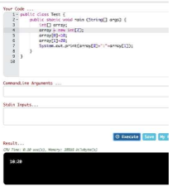Given the following code:

What is the output?

A

4

4

B

3

5

C

4

7

D

5

4

E

4

5

F

4

21

118.

CORRECT ANSWERS: B, C

EXPLANATION:

Explanation:

FIFTH TEST - QUESTION 42/77: Select Multiple Answers

You are developing a banking module. You have developed a class named ccMask that has a maskcc

method.

Given the code fragment:

You must ensure that the maskcc method returns a string that hides all digits of the credit card number

except the four last digits (and the hyphens that separate each group of four digits).

Which two code fragments should you use at line n1, independently, to achieve this requirement?

A

Option A

B

Option B

C

Option C

D

Option D

119. CORRECT ANSWER: B

EXPLANATION:

Explanation:

FIFTH TEST - QUESTION 43/77:

Given:

Which statement is true?

A

Both p and s are accessible by obj.

B

Only s is accessible by obj.

C

Both r and s are accessible by obj.

D

p, r, and s are accessible by obj.

120.

CORRECT ANSWER: C

EXPLANATION:

Explanation:

FIFTH TEST - QUESTION 44/77:

Given:

What is the result?

A

Base

DerivedA

B

Base

DerivedB

C

DerivedB

DerivedB

D

DerivedB

DerivedA

E

A classcast Exception is thrown at runtime.

121.

CORRECT ANSWER: C

EXPLANATION:

Explanation:

FIFTH TEST - QUESTION 45/77:

Given the code fragment:

What is the result?

A

Execution terminates in the first catch statement, and caught a RuntimeException is printed to the

console.

B

Execution terminates in the second catch statement, and caught an Exception is printed to the console.

C

A runtime error is thrown in the thread "main".

D

Execution completes normally, and Ready to use is printed to the console.

E

The code fails to compile because a throws keyword is required.

122.

CORRECT ANSWER: D

EXPLANATION:

Explanation:

FIFTH TEST - QUESTION 46/77:

Given:

What is the result?

A

Option A

B

Option B

C

Option C

D

Option D

123.

CORRECT ANSWER: C

EXPLANATION:

Explanation:

FIFTH TEST - QUESTION 47/77:

Given the code fragments:

Which code fragment, when inserted at line n1, enables the code to print Hank?

A

checkAge (iList, ( ) -> p. get Age ( ) > 40);

B

checkAge(iList, Person p -> p.getAge( ) > 40);

C

checkAge (iList, p -> p.getAge ( ) > 40);

D

checkAge(iList, (Person p) -> { p.getAge() > 40; });

124.

CORRECT ANSWER: C

EXPLANATION:

Explanation:

FIFTH TEST - QUESTION 48/77:

Given the code fragment:

What is the result?

A

A B C

B

A B C D E

C

A B D E

D

Compilation fails.

125.

CORRECT ANSWER: C

EXPLANATION:

Explanation:

FIFTH TEST - QUESTION 49/77:

Given the code fragment:

What is the result?

A

true true

B

true false

C

false false

D

false true

126.

CORRECT ANSWER: B

EXPLANATION:

Explanation:

FIFTH TEST - QUESTION 50/77:

Given the code fragment:

Which code fragment, when inserted at line n1, enables the App class to print Equal?

A

Option A

B

Option B

C

Option C

D

Option D

127CORRECT ANSWER: B

EXPLANATION:

Explanation:

FIFTH TEST - QUESTION 51/77:

Given:

What is the result?

A

Option A

B

Option B

C

Option C

D

Option D.

128.

CORRECT ANSWER: D

EXPLANATION:

Explanation:

FIFTH TEST - QUESTION 52/77:

Given the code fragment:

What is the result?

A

Element 0

Element 1

B

Null element 0

Null element 1

C

Null

Null

D

A NullPointerException is thrown at runtime.

129.

CORRECT ANSWER: D

EXPLANATION:

Explanation:

FIFTH TEST - QUESTION 53/77:

Given:

What is the result?

A

10:20

B

0:20

C

Compilation fails at line n1

D

Compilation fails at line n2

130.

CORRECT ANSWER: C

EXPLANATION:

Explanation:

FIFTH TEST - QUESTION 54/77:

Given the definitions of the MyString class and the Test class:

What is the result?

A

Option A

B

Option B

C

Option C

D

Option D

131.

CORRECT ANSWERS: A, D, F

EXPLANATION:

Explanation:

FIFTH TEST - QUESTION 55/77: Select Multiple Answers

Given the code fragment:

Which three lines fail to compile?

A

Line 7

B

Line 8

C

Line 9

D

Line 10

E

Line 11

F

Line 12

132.

CORRECT ANSWER: C

EXPLANATION:

Explanation:

FIFTH TEST - QUESTION 56/77:

Given:

What is the result?

A

int main 1

B

Object main 1

C

String main 1

D

Compilation fails

E

An exception is thrown at runtime

133.

CORRECT ANSWER: A

EXPLANATION:

Explanation:

FIFTH TEST - QUESTION 57/77:

Given the code fragment:

Which option represents the state of the num array after successful completion of the outer loop?

A

Option A

B

Option B

C

Option C

D

Option D

134.

CORRECT ANSWER: D

EXPLANATION:

Explanation:

FIFTH TEST - QUESTION 58/77:

Given the code fragment:

What is the result?

A

Jesse 25

Walter 52

B

Compilation fails only at line n1

C

Compilation fails only at line n2

D

Compilation fails at both line n1 and line n2

135.

CORRECT ANSWER: C

EXPLANATION:

Explanation:

FIFTH TEST - QUESTION 59/77:

Given the following code for a Planet object:

What is the output?

A

Option A

B

Option B

C

Option C

D

Option D

E

Option E

136.

CORRECT ANSWER: A

EXPLANATION:

Explanation:

FIFTH TEST - QUESTION 60/77:

You are asked to develop a program for a shopping application, and you are given the following

information:

- The application must contain the classes Toy, EduToy, and ConsToy. The Toy class is the superclass

of the other two classes.

- The int caicuiatePrice (Toy t) method calculates the price of a toy.

- The void printToy (Toy t) method prints the details of a toy.

Which definition of the Toy class adds a valid layer of abstraction to the class hierarchy?

A

Option A

B

Option B

C

Option C

D

Option D

137CORRECT ANSWER: C

EXPLANATION:

Explanation:

FIFTH TEST - QUESTION 61/77:

Given the following code:

What are the values of each element in intArr after this code has executed?

A

15, 60, 45, 90, 75

B

15, 90, 45, 90, 75

C

15, 30, 75, 60, 90

D

15, 30, 90, 60, 90

E

15, 4, 45, 60, 90.

138.

CORRECT ANSWERS: B, E

EXPLANATION:

Explanation:

FIFTH TEST - QUESTION 62/77: Select Multiple Answers

Given the following array:

Which two code fragments, independently, print each element in this array?

A

Option A

B

Option B

C

Option C

D

Option D

E

Option E

F

Option F

139.

CORRECT ANSWER: A

EXPLANATION:

Explanation:

FIFTH TEST - QUESTION 63/77:

Given the content of three files:

Which statement is true?

A

Only the A.Java file compiles successfully.

B

Only the B.java file compiles successfully.

C

Only the C.java file compiles successfully.

D

The A.Java and B.java files compile successfully.

E

The B.java and C.java files compile successfully.

F

The A.Java and C.java files compile successfully.

140.

CORRECT ANSWERS: D, E

EXPLANATION:

Explanation:

FIFTH TEST - QUESTION 64/77: Select Multiple Answers

Given the code fragment:

int[] array = {1, 2, 3, 4, 5};

And given the requirements:

1. Process all the elements of the array in the order of entry.

2. Process all the elements of the array in the reverse order of entry.

3. Process alternating elements of the array in the order of entry.

Which two statements are true?

A

Requirements 1, 2, and 3 can be implemented by using the enhanced for loop.

B

Requirements 1, 2, and 3 can be implemented by using the standard for loop.

C

Requirements 2 and 3 CANNOT be implemented by using the standard for loop.

D

Requirement 1 can be implemented by using the enhanced for loop.

E

Requirement 3 CANNOT be implemented by using either the enhanced for loop or the standard for

loop.

14CORRECT ANSWER: A

EXPLANATION:

Explanation:

FIFTH TEST - QUESTION 65/77:

Given:

What is the result?

A

400 200

B

200 200

C

400 400

D

Compilation fails.1.

142.

CORRECT ANSWER: D

EXPLANATION:

Explanation:

FIFTH TEST - QUESTION 66/77:

Given the following class declarations:

- public abstract class Animal

- public interface Hunter

- public class Cat extends Animal implements Hunter

- public class Tiger extends Cat

Which answer fails to compile?

A

Option A

B

Option B

C

Option C

D

Option D

E

Option E

143.

CORRECT ANSWER: C

EXPLANATION:

Explanation:

Reference: http://www.math.uni-hamburg.de/doc/java/tutorial/getStarted/intro/definition.html

Java bytecodes help make "write once, run anywhere" possible. You can compile your program into

bytecodes on any platform that has a Java compiler. The bytecodes can then be run on any

implementation of the Java VM. That means that as long as a computer has a Java VM, the same program

written in the Java programming language can run on Windows 2000, a Solaris workstation, or on an iMac.

FIFTH TEST - QUESTION 67/77:

Which statement is true about Java byte code?

A

It can run on any platform.

B

It can run on any platform only if it was compiled for that platform.

C

It can run on any platform that has the Java Runtime Environment.

D

It can run on any platform that has a Java compiler.

E

It can run on any platform only if that platform has both the Java Runtime Environment and a Java

compiler.

144.

CORRECT ANSWER: A

EXPLANATION:

Explanation:

FIFTH TEST - QUESTION 68/77:

Given:

How many MarkList instances are created in memory at runtime?

A

1

B

2

C

3

D

4

145.

CORRECT ANSWER: D

EXPLANATION:

Explanation:

FIFTH TEST - QUESTION 69/77:

Given:

What is the result?

A

Area is 6.0

B

Area is 3.0

C

Compilation fails at line n1

D

Compilation fails at line n2.

146.

CORRECT ANSWERS: A, B, F

EXPLANATION:

Explanation:

FIFTH TEST - QUESTION 70/77: Select Multiple Answers

Given the code fragment:

Which three code fragments can be independently inserted at line n1 to enable the code to print one?

A

Byte x = 1;

B

short x = 1;

C

String x = "1";

D

Long x = 1;

E

Double x = 1;

F

Integer x = new Integer ("1");

147.

CORRECT ANSWER: A

EXPLANATION:

Explanation:

FIFTH TEST - QUESTION 71/77:

Given:

What is the result?

A

True false

B

True null

C

Compilation fails

D

A NullPointerException is thrown at runtime

148.

CORRECT ANSWER: B

EXPLANATION:

Explanation:

FIFTH TEST - QUESTION 72/77:

Given the following code for the classes MyException and Test:

What is the result?

A

A

B

B

C

Either A or B

D

A B

E

A compile time error occurs at line n1

149.

CORRECT ANSWER: C

EXPLANATION:

Explanation:

FIFTH TEST - QUESTION 73/77:

Given:

What is the result?

A

myStr: 9009, myNum: 9009

B

myStr: 7007, myNum: 7007

C

myStr: 7007, myNum: 9009

D

Compilation fails

150.

CORRECT ANSWERS: C, D

EXPLANATION:

Explanation:

Reference: https://www.cs.princeton.edu/courses/archive/fall98/cs441/mainus/node5.html

FIFTH TEST - QUESTION 74/77: Select Multiple Answers

Which two are benefits of polymorphism?

A

Faster code at runtime

B

More efficient code at runtime

C

More dynamic code at runtime

D

More flexible and reusable code

E

Code that is protected from extension by other classes

151.

CORRECT ANSWER: A

EXPLANATION:

Explanation:

FIFTH TEST - QUESTION 75/77:

Given the code fragment:

What is the result?

A

1:2:3:4:5:

B

1:2:3:

C

Compilation fails.

D

An ArrayoutofBoundsException is thrown at runtime.

152.

CORRECT ANSWER: C

EXPLANATION:

Explanation:

FIFTH TEST - QUESTION 76/77:

Given:

What is the result?

A

true:true

B

true:false

C

false:true

D

false:false

153.

CORRECT ANSWERS: C, E

EXPLANATION:

Explanation:

FIFTH TEST - QUESTION 77/77: Select Multiple Answers

Given the following classes:

Which two options fail to compile when placed at line n1 of the main method?

A

employee.salary = 50_000;

B

director.salary = 80_000;

C

employee.budget = 200_000;

D

manager.budget = 1_000_000;

E

manager.stockOption = 500;

F

director.stockOptions = 1_000;

Sixth Test

154.

CORRECT ANSWER: A

EXPLANATION:

Explanation:

Reference: https://docs.oracle.com/javase/tutorial/getStarted/application/

SIXTH TEST - QUESTION 1/65:

Which one of the following code examples uses valid Java syntax?

A

Option A

B

Option B

C

Option C

D

Option D

155.

CORRECT ANSWER: C

EXPLANATION:

Explanation:

SIXTH TEST - QUESTION 2/65:

Given the code fragment:

What is the result?

A

1324

B

2413

C

2313

D

4231

156.

CORRECT ANSWER: D

EXPLANATION:

Explanation:

SIXTH TEST - QUESTION 3/65:

Given:

What is the result?

A

An exception is thrown at runtime.

B

Initialized

Started

Initialized

C

Initialized

Started

D

Compilation fails.

157.

CORRECT ANSWER: E

EXPLANATION:

Explanation:

SIXTH TEST - QUESTION 4/65:

Given the code fragment:

What is the result?

A

Answer = 0

B

Invalid calculation

C

Compilation fails only at line n1.

D

Compilation fails only at line n2.

E

Compilation fails only at line n1 and line2.

158.

CORRECT ANSWER: D

EXPLANATION:

Explanation:

SIXTH TEST - QUESTION 5/65:

Given:

What is the result?

A

100 0 : 100 200:

B

100 0 : 100 0 :

C

100 200 : 100 200 :

D

100 200 : 100 0 :

159.

CORRECT ANSWER: C

EXPLANATION:

Explanation:

SIXTH TEST - QUESTION 6/65:

Given:

What is the result?

A

e, e

i, o

B

a, e

i, o

C

a,e

o, o

D

e, e

o, o

160.

CORRECT ANSWER: C

EXPLANATION:

Explanation:

SIXTH TEST - QUESTION 7/65:

Given the code fragment:

What is the result if the integer aVar is 9?

A

Compilation fails.

B

10 Hello Universe!

C

10 Hello World!

D

9 Hello World!

161.

CORRECT ANSWER: D

EXPLANATION:

Explanation:

SIXTH TEST - QUESTION 8/65:

Given:

What is the result?

A

Compilation fails.

B

11

C

8

D

9

E

10

162.

CORRECT ANSWER: D

EXPLANATION:

Explanation:

SIXTH TEST - QUESTION 9/65:

Given:

And given the commands:

javac Test.java

java Test TRUE null

What is the result?

A

TRUE null

B

true false

C

false false

D

true true

E

A ClassCastException is thrown at runtime.

163.

CORRECT ANSWER: D

EXPLANATION:

Explanation:

SIXTH TEST - QUESTION 10/65:

Given the code fragments:

Which modification enables the code to compile?

A

Replace line n1 with:

import p1.A;

Replace line n2 with:

import p1.A;

import p1.p2.B;

B

Replace line n1 with:

import p1;

Replace line n2 with:

import p1;

import p1.p2;

C

Replace line n1 with:

import p1.A;

Replace line n2 with:

import p1.*;

D

Replace line n1 with:

import p1.*;

Replace line n2 with:

import p1.p2.*;

164.

CORRECT ANSWER: C

EXPLANATION:

Explanation:

SIXTH TEST - QUESTION 11/65:

Which statement will empty the contents of a StringBuilder variable named sb?

A

sb. deleteAll ();

B

sb. delete (0, sb. size () );

C

sb. delete (0, sb. length () );

D

sb. removeAll ();

165.

CORRECT ANSWER: B

EXPLANATION:

Explanation:

SIXTH TEST - QUESTION 12/65:

Given:

Which code fragment can replace the if block?

A

stuff.equals ("TV"?) ? res= "Walter"? : stuff.equals ("Movie"?) ? res = "White"?

: res = "No Result"?;

B

res = stuff.equals ("TV"?) ? "Walter"? else stuff.equals ("Movie"?)? "White"? :

"No Result"?;

C

res = stuff.equals ("TV"?) ? stuff.equals ("Movie"?)? "Walter"? : "White"? : "No

Result"?;

D

res = stuff.equals ("TV"?)? "Walter"? : stuff.equals ("Movie"?)? "White"? : "No

Result"?;

167.

CORRECT ANSWER: A

EXPLANATION:

Explanation:

SIXTH TEST - QUESTION 13/65:

Given:

And the code fragment:

Which code fragment, when inserted at line 14, enables the code to print Mike Found?

A

int f = ps.indexOf (p2)

B

int f = ps.indexOf (Patient ("Mike"?) );

C

int f = ps.indexOf (new Patient "Mike"?) );

D

Patient p = new Patient ("Mike"?);

Int f = ps.indexOf (p)

168.

CORRECT ANSWER: D

EXPLANATION:

Explanation:

Reference http://www.dummies.com/programming/java/switch-statements-in-java/

SIXTH TEST - QUESTION 14/65:

Which statement is true about the switch statement?

A

It must contain the default section.

B

The break statement, at the end of each case block, is mandatory.

C

Its case label literals can be changed at runtime.

D

Its expression must evaluate to a single value.

169.

CORRECT ANSWER: A

EXPLANATION:

Explanation:

SIXTH TEST - QUESTION 15/65:

Given:

And given the code fragment:

Which two modifications enable the code to print the following output?

Canine 60 Long

Feline 80 Short

A

Replace line n1 with:

super ();

this.bounds = bounds;

B

Replace line n1 with:

this.bounds = bounds;

super ();

C

Replace line n2 with:

super (type, maxSpeed);

this (bounds);

D

Replace line n1 with:

this ("Canine"?, 60);

this.bounds = bounds

E

Replace line n2 with:

super (type, maxSpeed);

this.bounds = bounds;

170.

CORRECT ANSWER: C

EXPLANATION:

Explanation:

SIXTH TEST - QUESTION 16/65:

Given the code fragment:

What is the result?

A

Invalid Name

B

Invalid Name

omas

C

Invalid Name

omas

null

null

D

omas

ter

seph

171.

CORRECT ANSWER: E

EXPLANATION:

Explanation:

SIXTH TEST - QUESTION 17/65:

Given the code fragment:

Test.java

Which is the result?

A

Compilation fails in the Employee class.

B

null : 0: 0

Jack : 50 : 0

Chloe : 40 : 5000

C

null : 0 : 0

Jack : 50 : 2000

Chloe : 40 : 5000

D

Compilation fails in the Test class.

E

Both the Employee class and the test class fail to compile.

172.

CORRECT ANSWER: C

EXPLANATION:

Explanation:

SIXTH TEST - QUESTION 18/65:

Given the code fragments:

Which modification enables the code to compile?

A

Replace line n1 with:

import p1.*;

Replace line n2 with:

import p1. p2.*;

B

Replace line n1 with:

import p1. A;

Replace line n2 with:

import p1.*;

C

Replace line n1 with:

import p1. A;

Replace line n2 with:

import p1. A;

import p1. p2.B ;

D

Replace line n1 with:

import p1;

Replace line n2 with:

import p1;

import p1. p2;

173.

CORRECT ANSWER: B

EXPLANATION:

Explanation:

SIXTH TEST - QUESTION 19/65:

Given:

What is the result?

A

A

B

B

A

C

C

C

C

D

A ClassCastException is thrown only at line n1.

E

A ClassCastException is thrown only at line n2.

174.

CORRECT ANSWER: D

EXPLANATION:

Explanation:

SIXTH TEST - QUESTION 20/65:

Given:

What is the result?

A

int sum is 30

float sum is 30.0

B

int sum is 30

double sum is 30.0

C

integer sum is 30

double sum is 30.0

D

integer sum is 30

float sum is 30.0

175.

CORRECT ANSWER: E

EXPLANATION:

Explanation:

SIXTH TEST - QUESTION 21/65:

Given the code fragment:

Which two modifications should you make so that the code compiles successfully?

A

Option A

B

Option B

C

Option C

D

Option D

E

Option E

176.

CORRECT ANSWER: A

EXPLANATION:

Explanation:

SIXTH TEST - QUESTION 22/65:

You are asked to create a method that accepts an array of integers and returns the highest value from that

array.

Given the code fragment:

Which method signature do you use at line n1?

A

public int findMax (int [] numbers)

B

static int[] findMax (int max)

C

static int findMax (int [] numbers)

D

final int findMax (int [] )

177.

CORRECT ANSWERS: A, C, E

EXPLANATION:

Explanation:

SIXTH TEST - QUESTION 23/65: Select Multiple Answers

Which three statements are true about the structure of a Java class?

A

A public class must have a main method.

B

A class can have only one private constructor.

C

A method can have the same name as a field.

D

A class can have overloaded static methods.

E

The methods are mandatory components of a class.

F

The fields need not be initialized before use.

178.

CORRECT ANSWER: C

EXPLANATION:

Explanation:

SIXTH TEST - QUESTION 24/65:

Given the code fragment:

What is the result?

A

Option A

B

Option B

C

Option C

D

Option D

179.

CORRECT ANSWER: B

EXPLANATION:

Explanation:

SIXTH TEST - QUESTION 25/65:

Given:

What is the result?

A

Compilation fails at line n3 and line n4.

B

Compilation fails at line n1 and line n2.

C

Welcome Visit Count:1

Welcome Visit Count: 2

D

Welcome Visit Count:1

Welcome Visit Count: 2

180.

CORRECT ANSWER: D

EXPLANATION:

Explanation:

SIXTH TEST - QUESTION 26/65:

Given the code fragment:

What is the result?

A

Compilation fails at both line n1 and line n2.

B

Compilation fails only at line n2.

C

Compilation fails only at line n1.

D

Jesse 25

Walter 52

181.

CORRECT ANSWER: B

EXPLANATION:

Explanation:

Reference:

SIXTH TEST - QUESTION 27/65:

Given the code fragment:

What is the result?

A

5 : 5

B

10 : 10

C

5 : 10

D

Compilation fails.

182.

CORRECT ANSWER: F

EXPLANATION:

Explanation:

SIXTH TEST - QUESTION 28/65:

Given the code fragment:

What is the result?

A

A NullPointerException is thrown at runtime.

B

[1, 2, 4]

C

[1, 2, 4, null ]

D

[1, 3, 4, null ]

E

[1, 3, 4 ]

F

Compilation fails.

183.

CORRECT ANSWER: B

EXPLANATION:

Explanation:

SIXTH TEST - QUESTION 29/65:

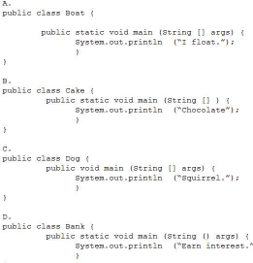Given:

What is the result?

A

10 20 30 40

B

0 0 30 40

C

Compilation fails.

D

An exception is thrown at runtime.

184.

CORRECT ANSWER: D

EXPLANATION:

Explanation:

SIXTH TEST - QUESTION 30/65:

Which code fragment causes a compilation error?

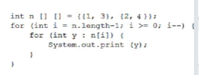

A

Option A

B

Option B

C

Option C

D

Option D

E

Option E

185.

CORRECT ANSWER: A

EXPLANATION:

Explanation:

SIXTH TEST - QUESTION 31/65:

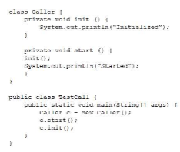Given:

What is the result?

A

c=

b = false

f = 0.0

B

c= null

b = true

f = 0.0

C

c=0

b = false

f = 0.0f

D

c= null

b = false

f = 0.0F

186.

CORRECT ANSWERS: C, E, F

EXPLANATION:

Explanation:

SIXTH TEST - QUESTION 32/65: Select Multiple Answers

Which three statements are true about exception handling?

A

Only unchecked exceptions can be rethrown.

B

All subclasses of the RuntimeException class are recoverable.

C

The parameter in a catch block is of Throwable type.

D

All subclasses of the RuntimeException class must be caught or declared to be thrown.

E

All subclasses of the Exception class except the RuntimeException class are checked exceptions.

F

All subclasses of the Error class are checked exceptions and are

187.

**CORRECT ANSWER: C**

**EXPLANATION:**

Explanation:

**SIXTH TEST - QUESTION 33/65:**

Given the code fragment:   
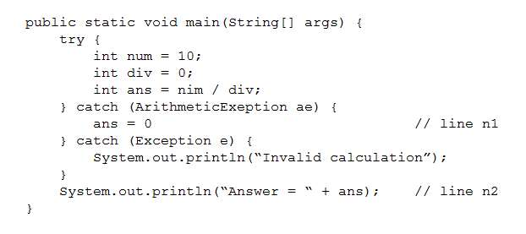  
Which code fragment, inserted at line n1, pints The Top element: 30?   
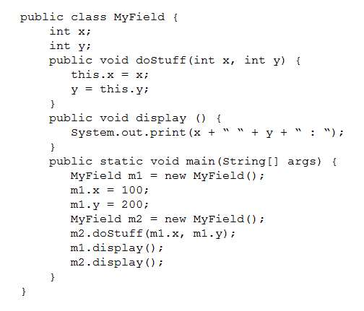

 A

Option A

 B

Option B

 C

Option C

 D

Option D

 E

Option E

188.

**CORRECT ANSWER: C**

**EXPLANATION:**

Explanation:

**SIXTH TEST - QUESTION 34/65:**

Given the code fragment:   
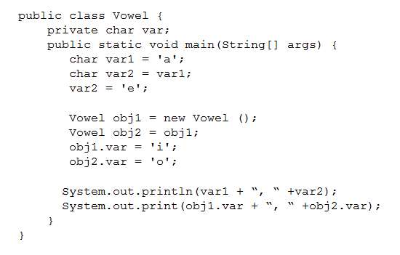  
What is the result?

 A

An exception is thrown at runtime.

 B

-1

 C

5

 D

0

189.

**CORRECT ANSWER: B**

**EXPLANATION:**

Explanation:

**SIXTH TEST - QUESTION 35/65:**

Given:   
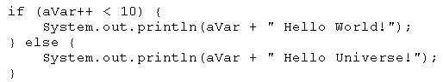  
What is the result?

 A

false, false

 B

false, true

 C

true, false

 D

true, true

190.

**CORRECT ANSWERS: B, C**

**EXPLANATION:**

Explanation:

**SIXTH TEST - QUESTION 36/65:***Select Multiple Answers*

Which two statements are true?

 A

Error class is unextendable.

 B

Error class is extendable.

 C

Error is a RuntimeException.

 D

Error is an Exception.

 E

Error is a Throwable.

191.

**CORRECT ANSWER: D**

**EXPLANATION:**

Explanation:

**SIXTH TEST - QUESTION 37/65:**

Given the code fragment:   
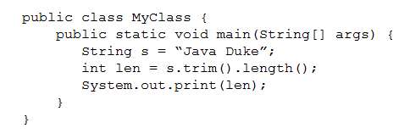  
What is the result?

 A

Compilation fails.

 B

0 Found

 C

1 Found

 D

3 Found

192.

**CORRECT ANSWER: C**

**EXPLANATION:**

Explanation:

**SIXTH TEST - QUESTION 38/65:**

Given the code fragment:   
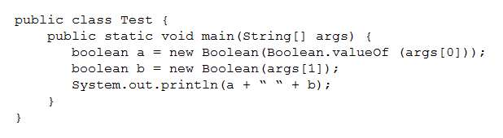  
What is the result?

 A

An exception is thrown at runtime.

 B

07-31-2014

 C

2014-07-31

 D

2014-09-30

193.

**CORRECT ANSWER: A**

**EXPLANATION:**

Explanation:

**SIXTH TEST - QUESTION 39/65:**

Given:   
https://www.certification-questions.com/images/java/dumps/1z0-808/image-143.jpg  
And given the commands: javac Test.java java Test What is the result?

 A

Java SE

 B

Java EE

 C

Compilation fails at line n1.

 D

A NullPointerException is thrown at runtime.

194.

**CORRECT ANSWER: A**

**EXPLANATION:**

Explanation:

**SIXTH TEST - QUESTION 40/65:**

Given:   
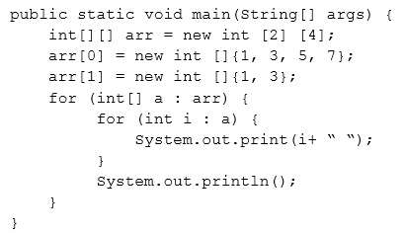  
And given the code fragment: Book book1 = new EBook (); Book1.readBook(); Which option enables the code to compile?   
https://www.certification-questions.com/images/java/dumps/1z0-808/image-145.jpg

 A

Option A

 B

Option B

 C

Option C

 D

Option D

195.

**CORRECT ANSWERS: B, C, E**

**EXPLANATION:**

Explanation:

**SIXTH TEST - QUESTION 41/65:***Select Multiple Answers*

Given the following class:   
https://www.certification-questions.com/images/java/dumps/1z0-808/image-146.jpg  
Which three pieces of code, when inserted independently, set the value of amount to 100?   
https://www.certification-questions.com/images/java/dumps/1z0-808/image-147.jpg

 A

Option A

 B

Option B

 C

Option C

 D

Option D

 E

Option E

 F

Option F

196.

**CORRECT ANSWER: E**

**EXPLANATION:**

Explanation:

**SIXTH TEST - QUESTION 42/65:**

Given the code fragments:   
https://www.certification-questions.com/images/java/dumps/1z0-808/image-148.jpg  
What is the result?

 A

Compilation fails only at line n2.

 B

RTool::export Tool::export

 C

Tool::export Tool:export

 D

Compilation fails only at line n1.

 E

Compilation fails at both line n1 and line n2.

197.

**CORRECT ANSWER: C**

**EXPLANATION:**

Explanation:

**SIXTH TEST - QUESTION 43/65:**

Given the code fragment:   
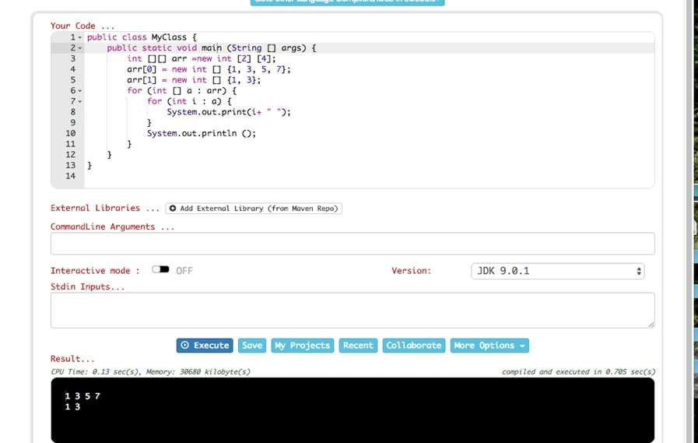  
What is the result?

 A

An exception is thrown at runtime.

 B

Compilation fails.

 C

13480.0

 D

13480.02

198.

**CORRECT ANSWER: D**

**EXPLANATION:**

Explanation:

**SIXTH TEST - QUESTION 44/65:**

Given:   
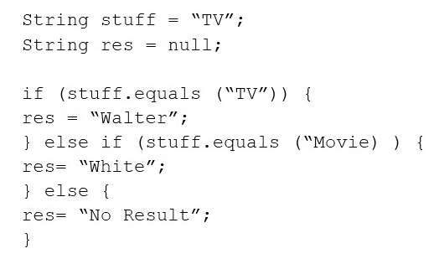  
And given the code fragment:   
https://www.certification-questions.com/images/java/dumps/1z0-808/image-151.jpg  
What is the result?

 A

300:300 200:300

 B

300:100 200:300

 C

300:0 0:300

 D

200:300 200:300

199.

**CORRECT ANSWER: A**

**EXPLANATION:**

Explanation:

**SIXTH TEST - QUESTION 45/65:**

Given:   
https://www.certification-questions.com/images/java/dumps/1z0-808/image-152.jpg  
And given the code fragment:   
https://www.certification-questions.com/images/java/dumps/1z0-808/image-153.jpg  
What is the result?

 A

C2C2

 B

C1C2

 C

C1C1

 D

Compilation fails

200.

**CORRECT ANSWER: A**

**EXPLANATION:**

Explanation:

**SIXTH TEST - QUESTION 46/65:**

Given:   
https://www.certification-questions.com/images/java/dumps/1z0-808/image-154.jpg  
Given the code fragment:   
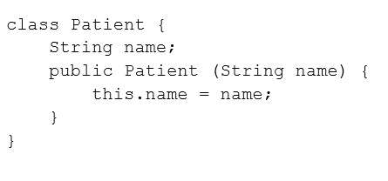  
Which two sets of actions, independently, enable the code fragment to print Fit?

 A

At line n1 insert: import clothing.Shirt; At line n2 insert: String color = getColor();

 B

At line n1 insert: import clothing.*; At line n2 insert: String color = Shirt.getColor();

 C

At line n1 insert: import static clothing.Shirt.getcolor; At line n2 insert: String color = getColor();

 D

At line n1 no changes required. At line n2 insert: String color = Shirt.getColor();

 E

At line n1 insert: import clothing; At line n2 insert: String color = Shirt.getColor();

**CORRECT ANSWER: C**

**EXPLANATION:**

Explanation:

**SIXTH TEST - QUESTION 47/65:**

Given the code fragments:   
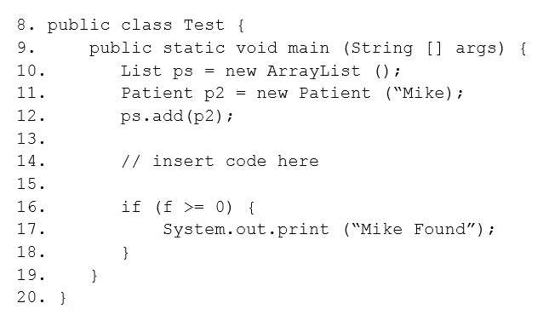  
And,   
https://www.certification-questions.com/images/java/dumps/1z0-808/image-157.jpg  
Which statement is true?

 A

After line 11, three objects are eligible for garbage collection.

 B

After line 11, two objects are eligible for garbage collection.

 C

After line 11, one object is eligible for garbage collection.

 D

After line 11, none of the objects are eligible for garbage collection.

**CORRECT ANSWER: B**

**EXPLANATION:**

Explanation:

**SIXTH TEST - QUESTION 48/65:**

Given the code fragment:   
https://www.certification-questions.com/images/java/dumps/1z0-808/image-158.jpg  
What is the result?

 A

3

 B

4

 C

-1

 D

Compilation fails.

**CORRECT ANSWER: C**

**EXPLANATION:**

Explanation:

**SIXTH TEST - QUESTION 49/65:**

Given the code fragment:   
https://www.certification-questions.com/images/java/dumps/1z0-808/image-159.jpg  
What is the result?

 A

2012-02-10

 B

2012-02-11

 C

Compilation fails

 D

A DateTimeException is thrown at runtime.

**CORRECT ANSWER: B**

**EXPLANATION:**

Explanation:   
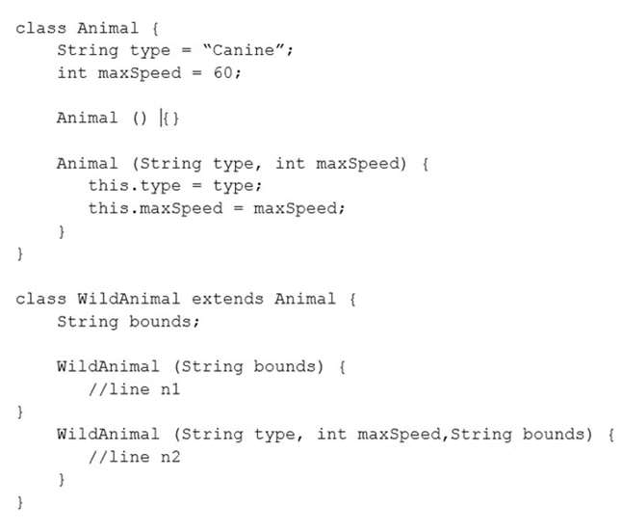

**SIXTH TEST - QUESTION 50/65:**

Given:   
https://www.certification-questions.com/images/java/dumps/1z0-808/image-160.jpg  
What is the result?

 A

10 : 30 : 6

 B

10 : 22 : 22

 C

10 : 22 : 20

 D

10 : 22 : 6

**CORRECT ANSWER: B**

**EXPLANATION:**

Explanation:

**SIXTH TEST - QUESTION 51/65:**

Given:   
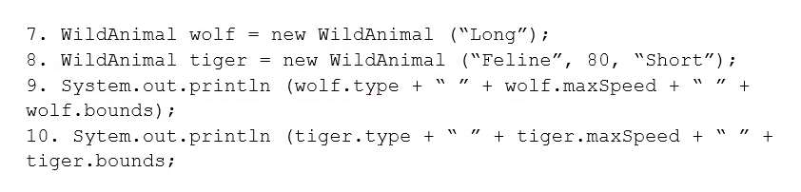  
And given the code fragment:   
https://www.certification-questions.com/images/java/dumps/1z0-808/image-163.jpg  
What is the result?

 A

Compilation fails at line n2.

 B

Read Book

 C

Read E-Book

 D

Compilation fails at line n1.

 E

Compilation fails at line n3.

**CORRECT ANSWERS: A, E**

**EXPLANATION:**

Explanation:

**SIXTH TEST - QUESTION 52/65:***Select Multiple Answers*

Given the following class:   
https://www.certification-questions.com/images/java/dumps/1z0-808/image-164.jpg  
Which two changes would encapsulate this class and ensure that the area field is always equal to length * height whenever the Rectangle class is used?

 A

Call the setArea method at the end of the setHeight method.

 B

Call the setArea method at the beginning of the setHeight method.

 C

Call the setArea method at the end of the setLength method.

 D

Call the setArea method at the beginning of the setLength method.

 E

Change the setArea method to private.

 F

Change the area field to public.

**CORRECT ANSWER: C**

**EXPLANATION:**

Explanation:

**SIXTH TEST - QUESTION 53/65:**

Given the code fragment:   
https://www.certification-questions.com/images/java/dumps/1z0-808/image-165.jpg  
What is the result?

 A

(green, red, yellow, cyan)

 B

(green, blue, yellow, cyan)

 C

(green, red, cyan, yellow)

 D

An IndexOutOfBoundsException is thrown at runtime.

**CORRECT ANSWERS: C, D, E**

**EXPLANATION:**

Explanation:

**SIXTH TEST - QUESTION 54/65:***Select Multiple Answers*

Given the code fragment:   
https://www.certification-questions.com/images/java/dumps/1z0-808/image-166.jpg  
Which three code fragments are valid at line n1?

 A

public static void insertToy() { /* code goes here */ }

 B

public abstract Toy getToy() { return new Toy(); }

 C

public void printToy();

 D

public int calculatePrice() { return price; }

 E

public abstract int computeDiscount();

**CORRECT ANSWER: B**

**EXPLANATION:**

Explanation:

**SIXTH TEST - QUESTION 55/65:**

Given:   
https://www.certification-questions.com/images/java/dumps/1z0-808/image-167.jpg  
What is the result?

 A

Compilation fails.

 B

3 5

 C

0 0

 D

9 25

**CORRECT ANSWERS: B, E**

**EXPLANATION:**

Explanation:

**SIXTH TEST - QUESTION 56/65:***Select Multiple Answers*

Given the code fragment:   
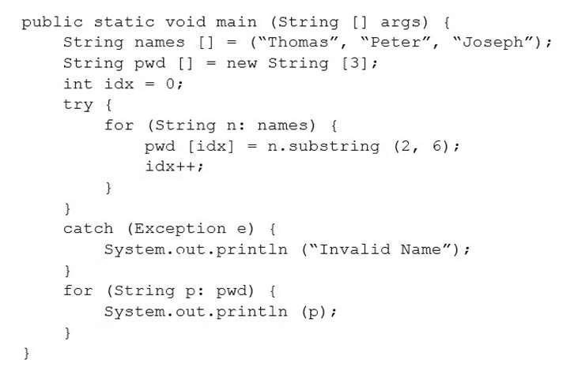  
Which two code fragments can be independently inserted at line n1 to enable the code to print the elements of the array in reverse order?

 A

while (x > 0) { x--; System.out.print(array[x]); }

 B

do { x--; System.out.print(array[x]); } while (x >= 0);

 C

while (x >= 0) { System.out.print(array[x]); x--; }

 D

do { System.out.print(array[x]); --x; } while (x >= 0);

 E

while (x > 0) { System.out.print(array[--x]); }

**CORRECT ANSWER: B**

**EXPLANATION:**

Explanation:

**SIXTH TEST - QUESTION 57/65:**

Given: class Test int a1; public static void doProduct(int a) { a = a * a; ) public static void doString(StringBuilder s) { s.append(" " + s); } public static void main(String[] args) { Test item = new Test(); item.a1 = 11; StringBuilder sb = new StringBuilder("Hello"?); Integer i = 10; doProduct(i); doString(sb); doProduct(item.a1); System.out.println(i + " " + sb + " " + item.a1); } } What is the result?

 A

10 Hello Hello 11

 B

10 Hello Hello 121

 C

100 Hello 121

 D

100 Hello Hello 121

 E

10 Hello 11

**CORRECT ANSWER: A**

**EXPLANATION:**

Explanation:

**SIXTH TEST - QUESTION 58/65:**

Given the code fragment:   
https://www.certification-questions.com/images/java/dumps/1z0-808/image-169.jpg  
What is the result?

 A

Compilation fails.

 B

Hi removed

 C

An UnsupportedOperationException is thrown at runtime.

 D

The program compiles, but it prints nothing.

**CORRECT ANSWERS: C, E**

**EXPLANATION:**

Explanation:

**SIXTH TEST - QUESTION 59/65:***Select Multiple Answers*

Which two class definitions fail to compile?

 A

abstract class A3 { private static int i; public void doStuff(){} public A3(){} }

 B

final class A1 { public A1(){} }

 C

public class A2 { private static int i; private A2(){} }

 D

class A4 { protected static final int i; private void doStuff(){} }

 E

final abstract class A5 { protected static int i; void doStuff(){} abstract void doIt(); }

**CORRECT ANSWER: A**

**EXPLANATION:**

Explanation:

**SIXTH TEST - QUESTION 60/65:**

Given:   
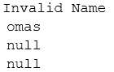  
What is the result?

 A

null Richard Donald

 B

Richard Donald

 C

Compilation fails.

 D

An ArrayIndexOutOfBoundsException is thrown at runtime.

 E

A NullPointerException is thrown at runtime.

**CORRECT ANSWER: C**

**EXPLANATION:**

Explanation:

**SIXTH TEST - QUESTION 61/65:**

The following grid shows the state of a 2D array:   
https://www.certification-questions.com/images/java/dumps/1z0-808/image-171.jpg  
This grid is created with the following code:   
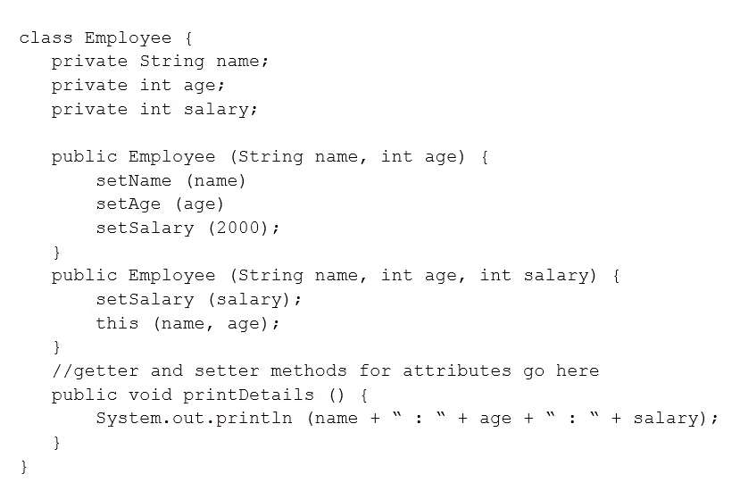  
Which line of code, when inserted in place of //line n1, adds an X into the grid so that the grid contains three consecutive X's?

 A

grid[1][3] = 'X';

 B

grid[3][1] = 'X';

 C

grid[0][2] = 'X';

 D

grid[2][0] = 'X';

 E

grid[1][2] = 'X';

**CORRECT ANSWER: C**

**EXPLANATION:**

Explanation:

**SIXTH TEST - QUESTION 62/65:**

Given:   
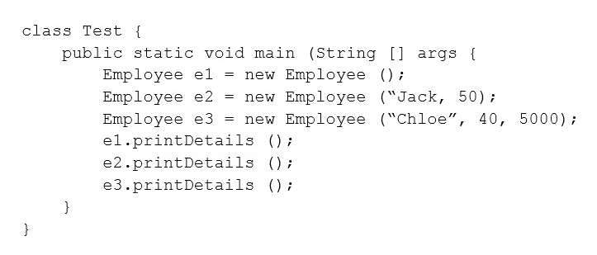  
What is the result?

 A

Hello Log 1:0

 B

Hello Log 2:1

 C

Welcome Log 2:1

 D

Welcome Log 1:0

**CORRECT ANSWER: A**

**EXPLANATION:**

Explanation:

**SIXTH TEST - QUESTION 63/65:**

Given the code snippet from a compiled Java source file:   
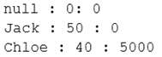  
Which command-line arguments should you pass to the program to obtain the following output? Arg is 2

 A

java MyFile 1 3 2 2

 B

java MyFile 2 2 2

 C

java MyFile 1 2 2 3 4

 D

java MyFile 0 1 2 3

**CORRECT ANSWER: A**

**EXPLANATION:**

Explanation:

**SIXTH TEST - QUESTION 64/65:**

Given the code fragment:   
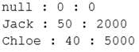  
What is the result?

 A

1 2 3 4 followed by an ArrayIndexOutOfBoundsException

 B

1 2 3

 C

1 2 3 4

 D

Compilation fails.

**CORRECT ANSWER: B**

**EXPLANATION:**

Explanation:

**SIXTH TEST - QUESTION 65/65:**

Given:   
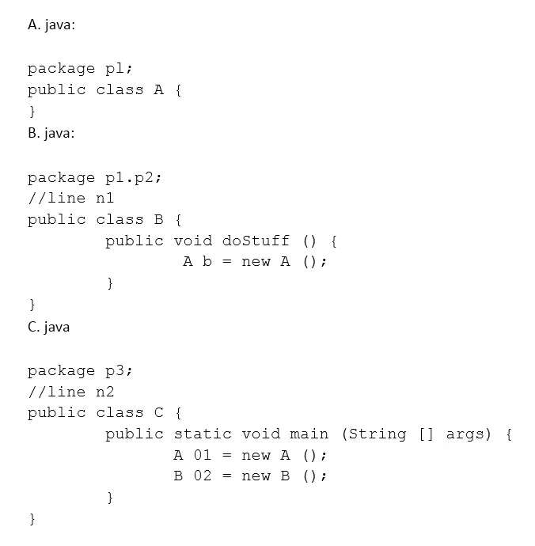  
What is the result?

 A

Compilation fails.

 B

false true

 C

true false

 D

true true

 E

false false